登录界面

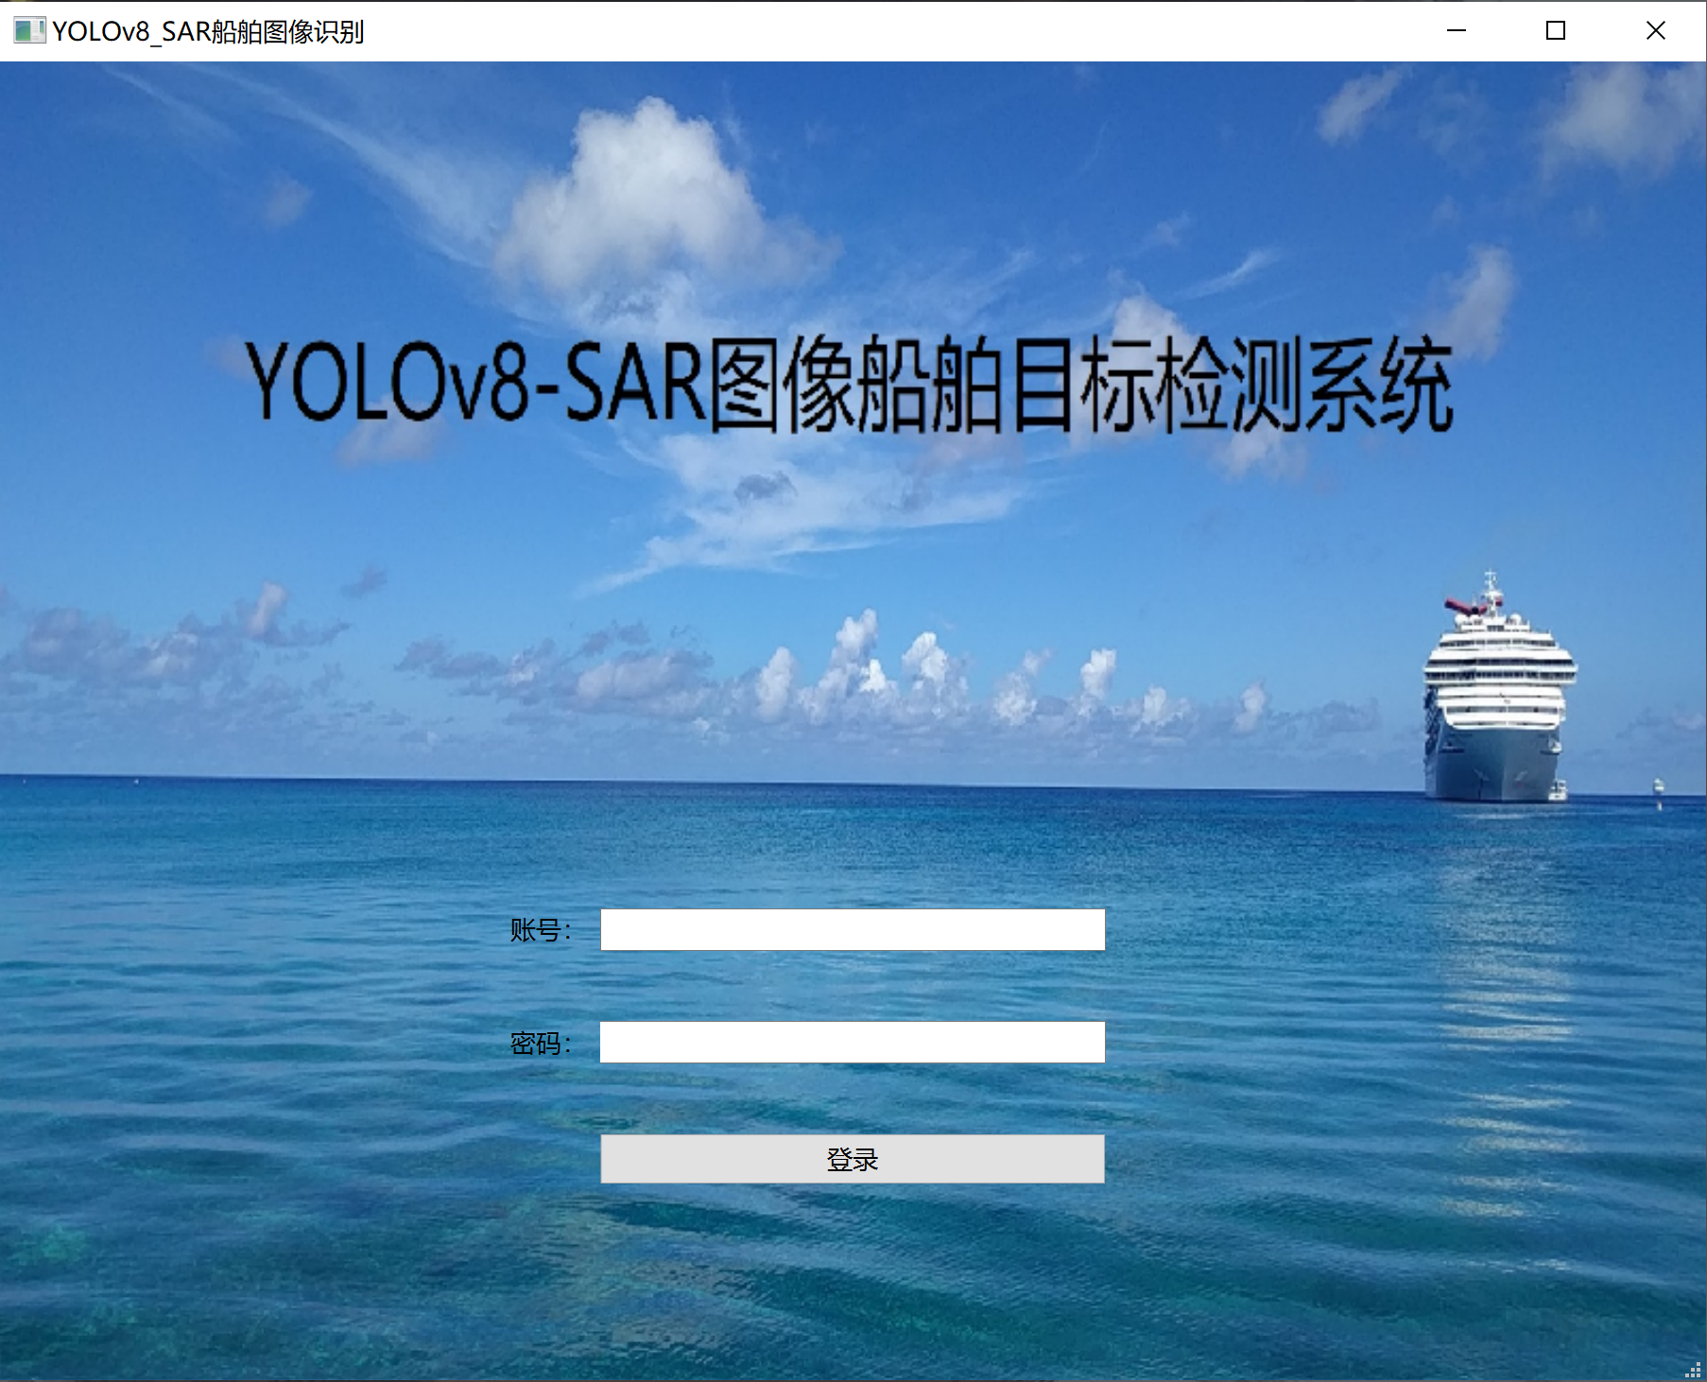

输入账号：admin

密码：123

后登入

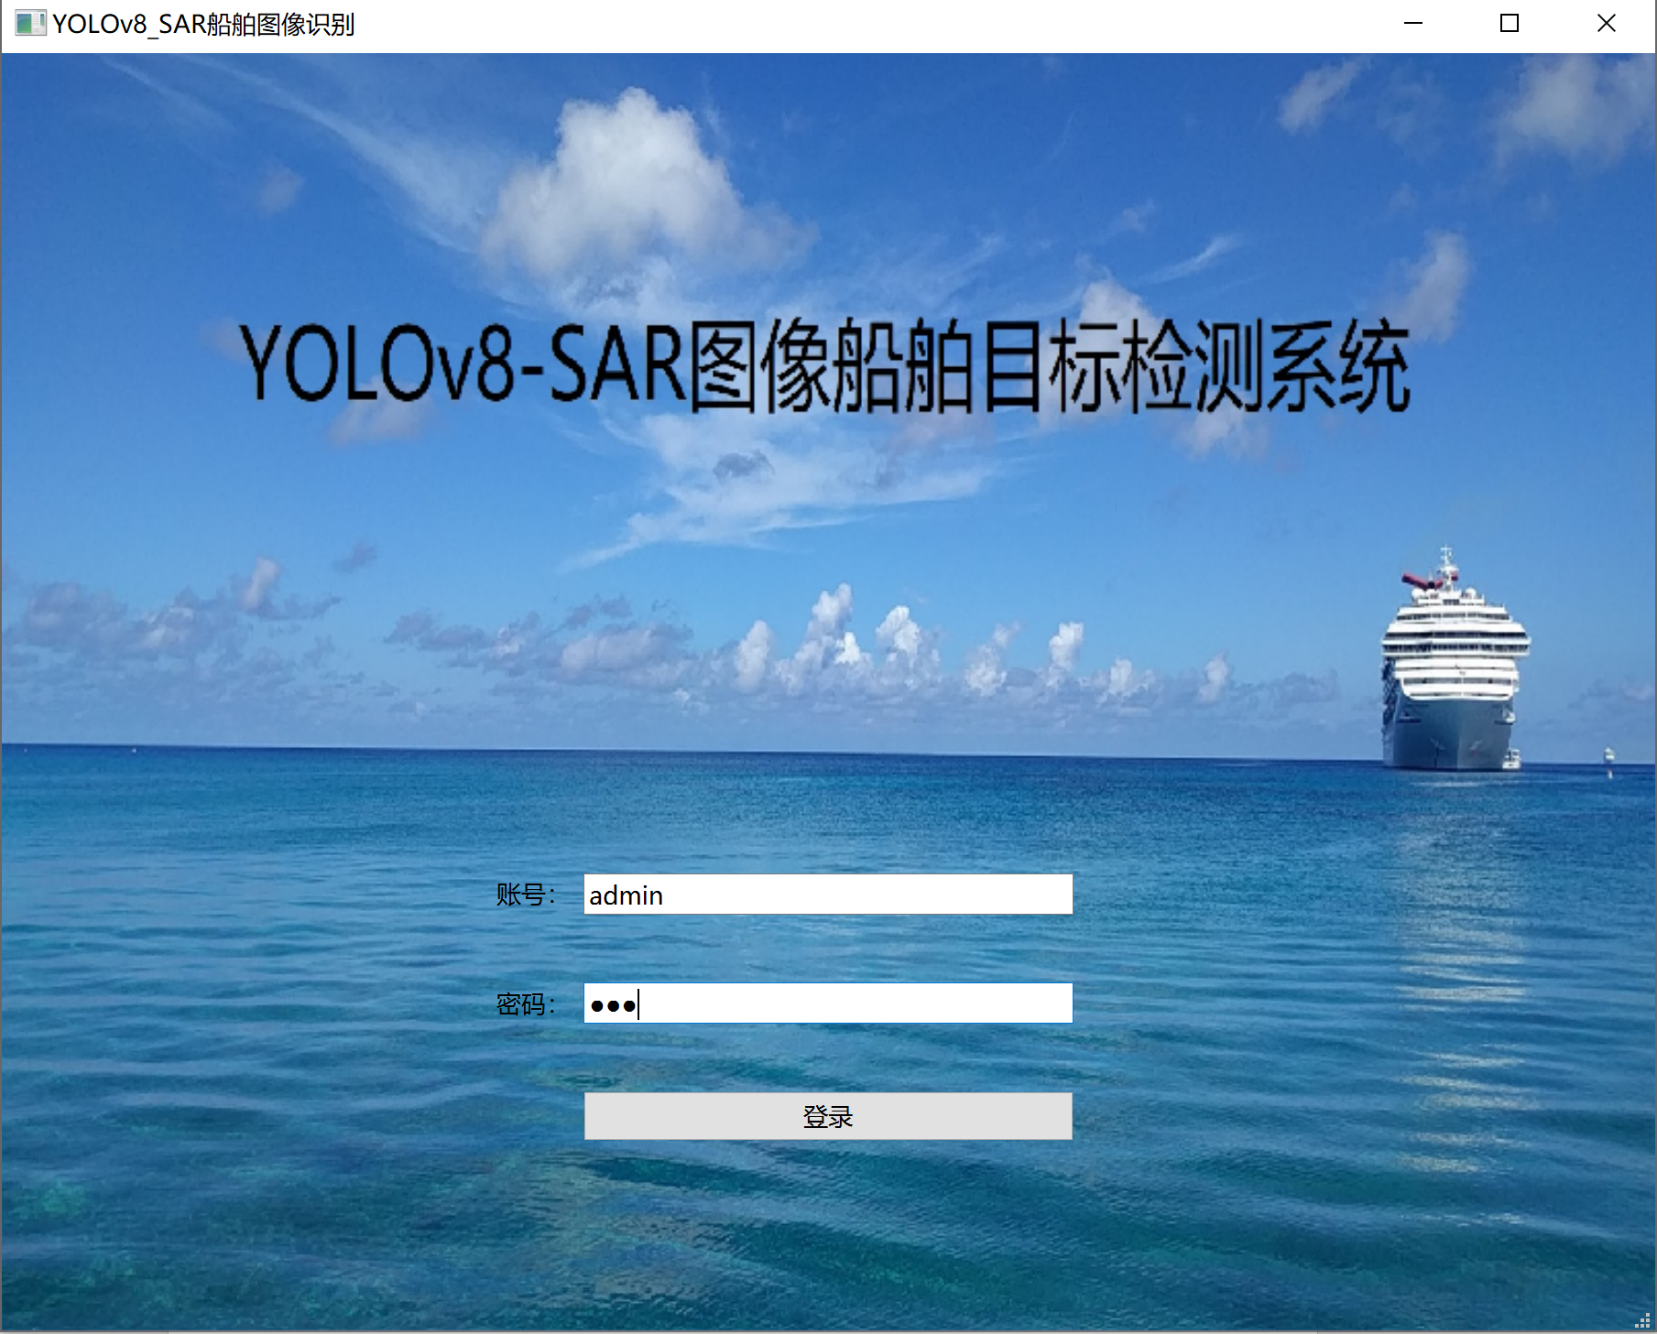

系统主页面

首先是‘图片’检测模式

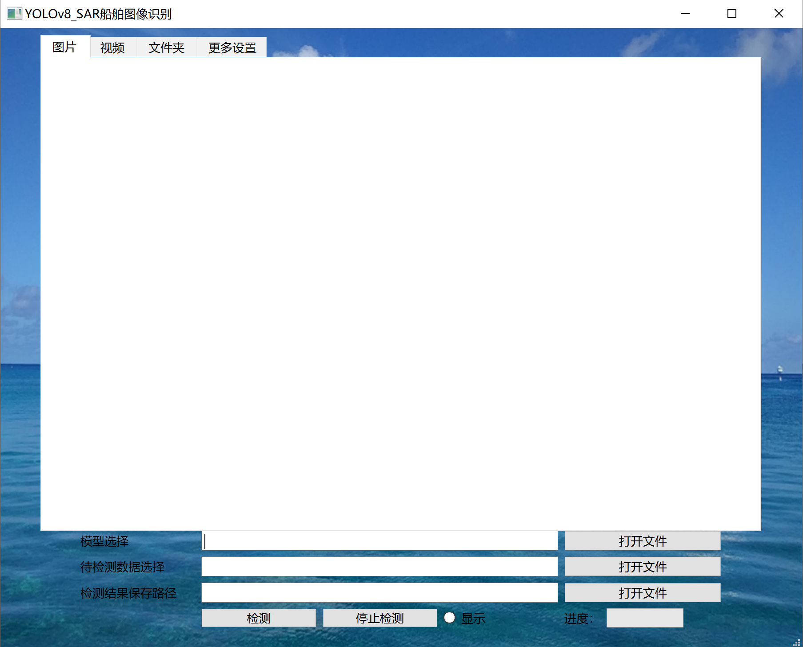

点击 ‘模型选择’右侧 ‘打开文件’按钮进行模型文件选择

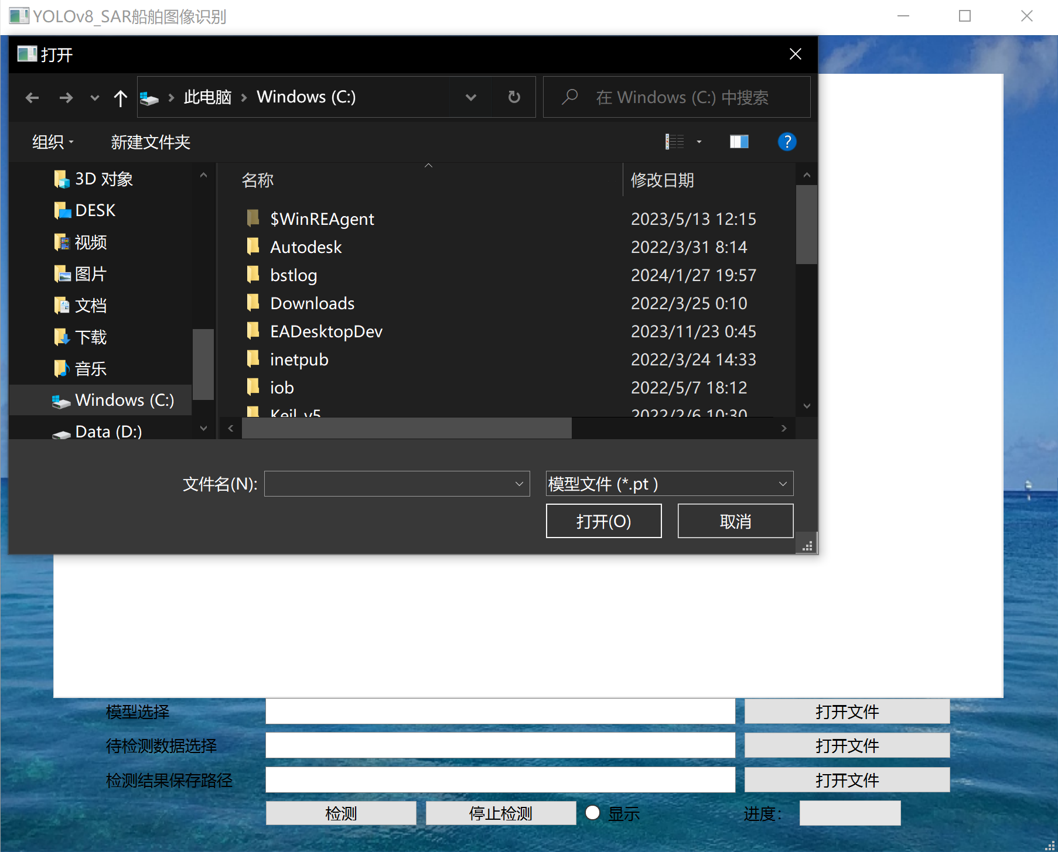

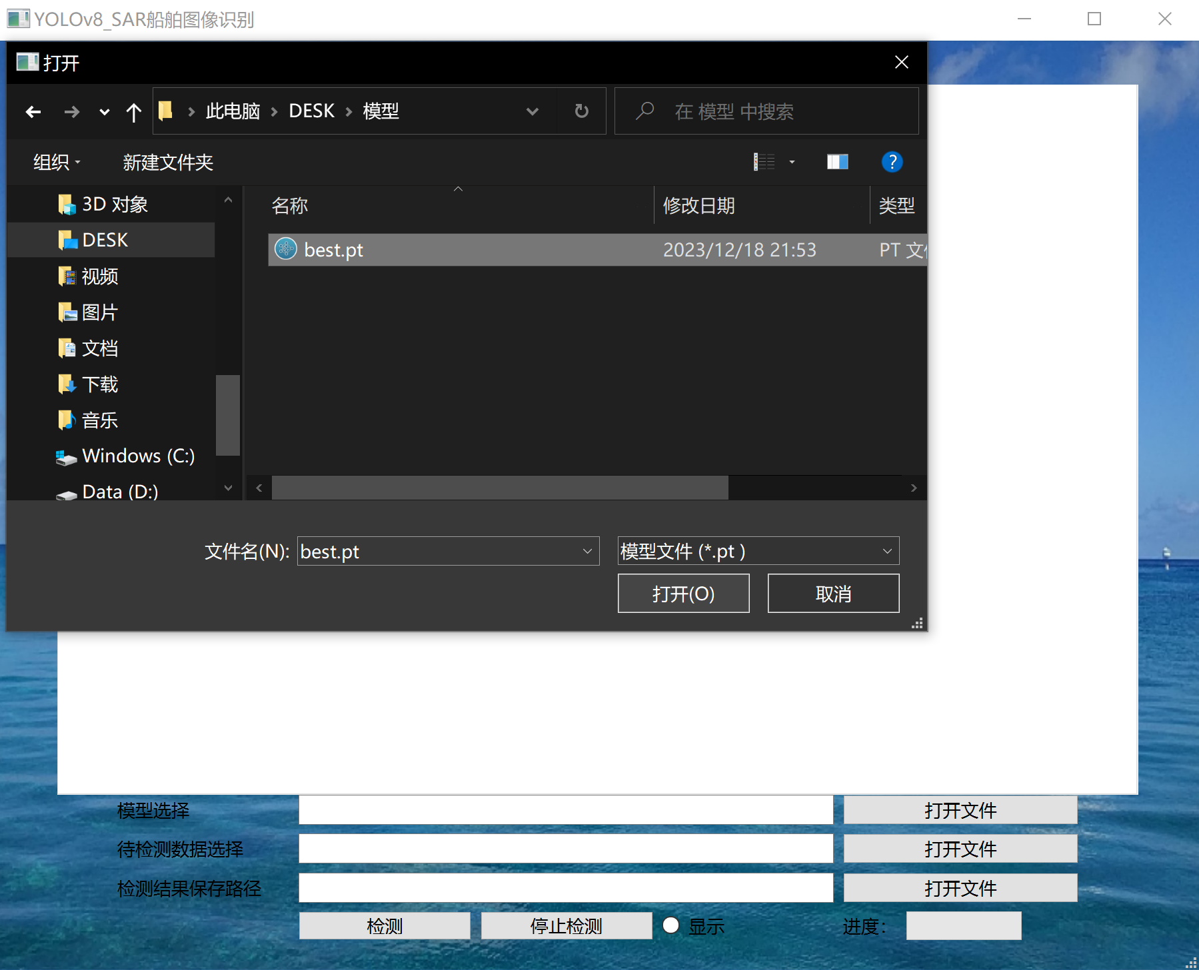

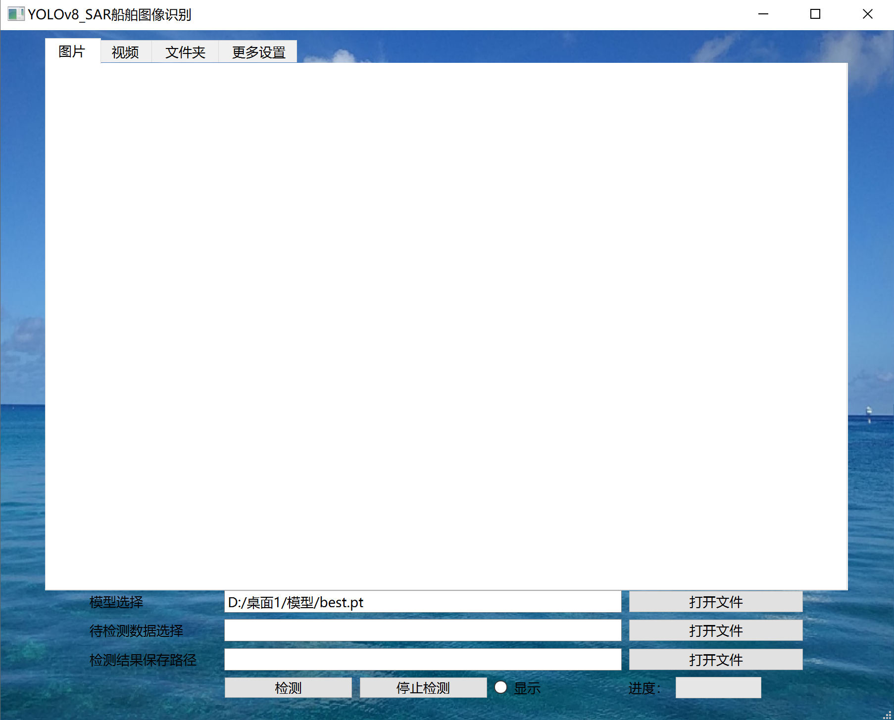

以此类推，依次选择待检测数据，检测结果保存路径

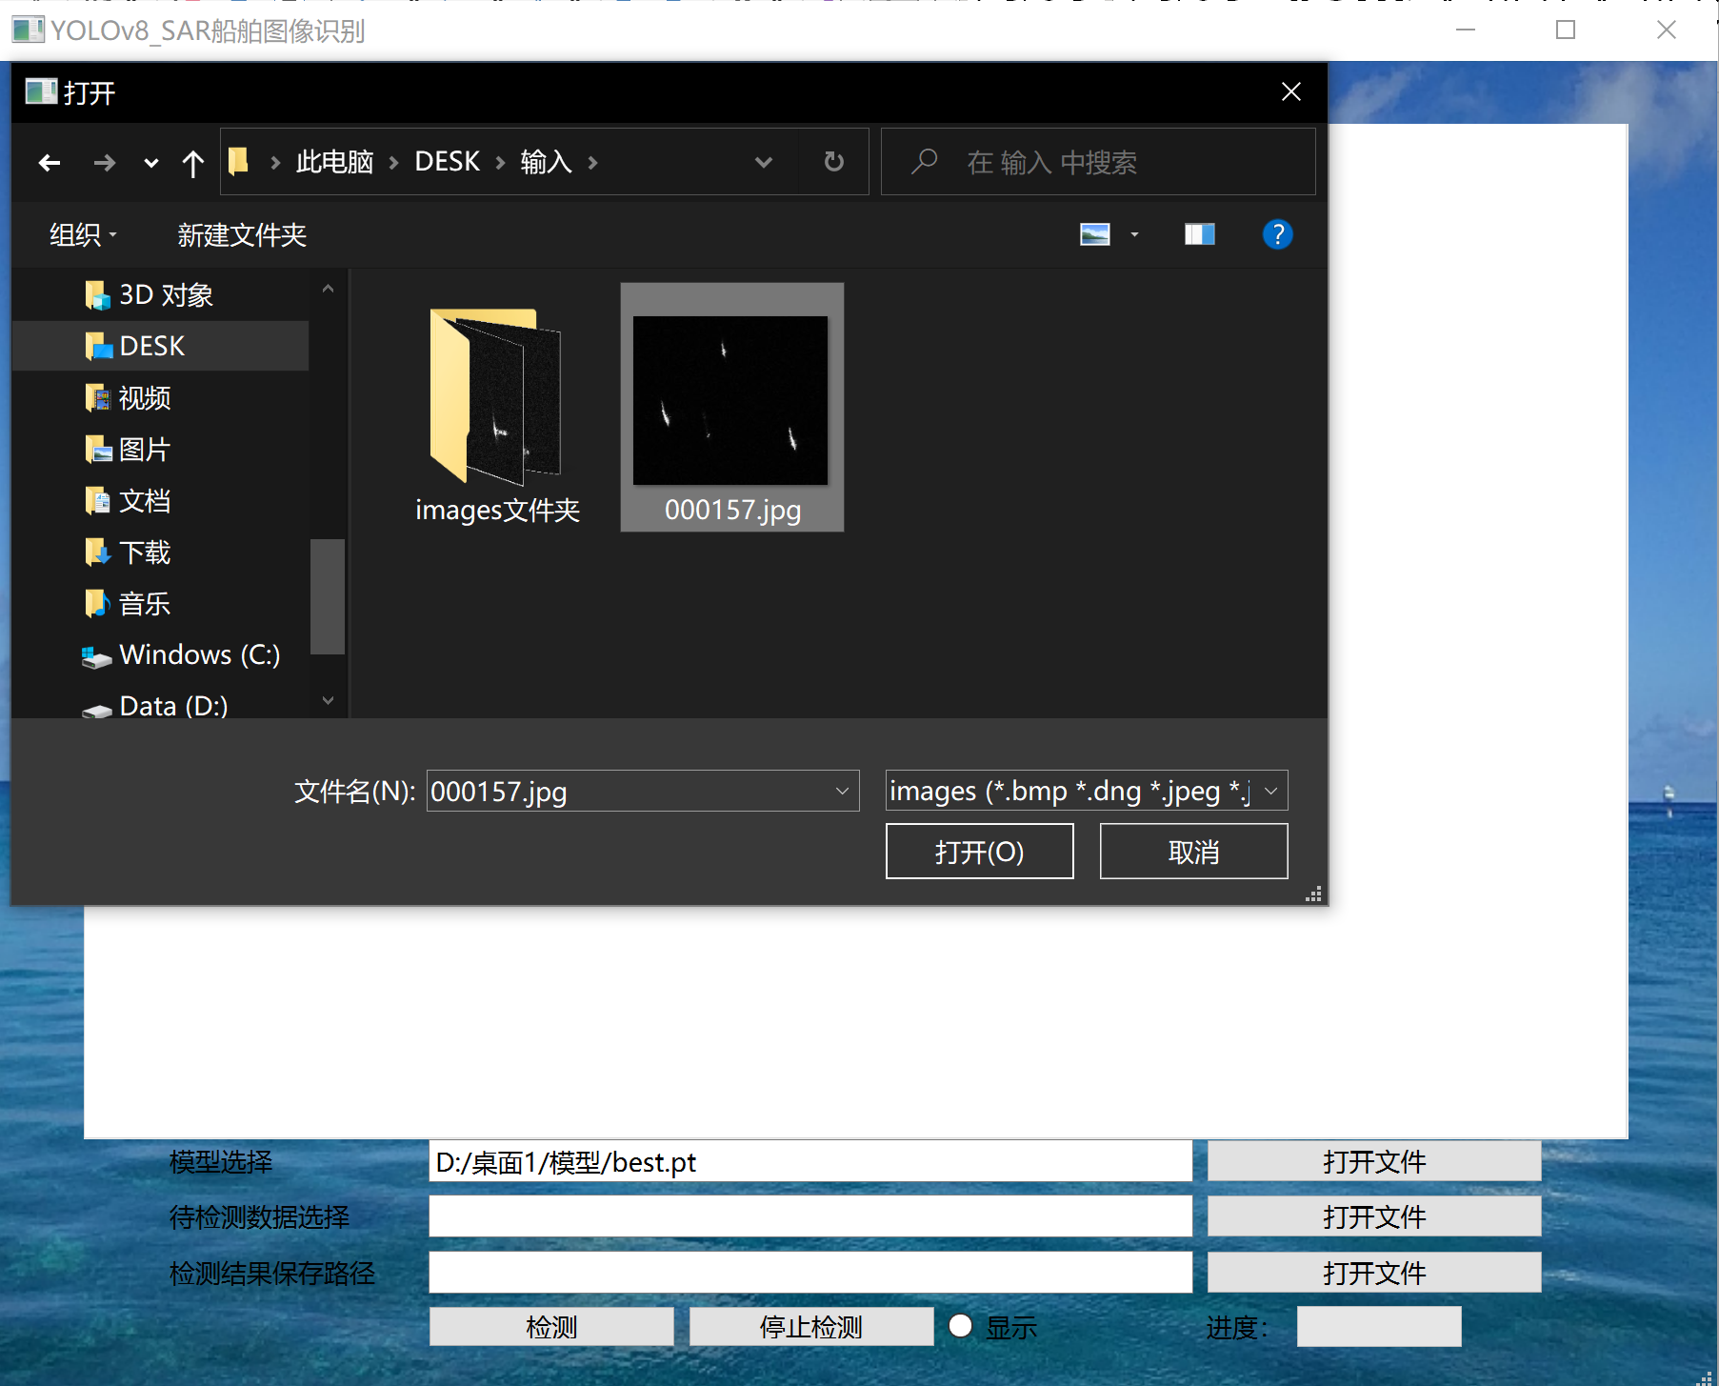

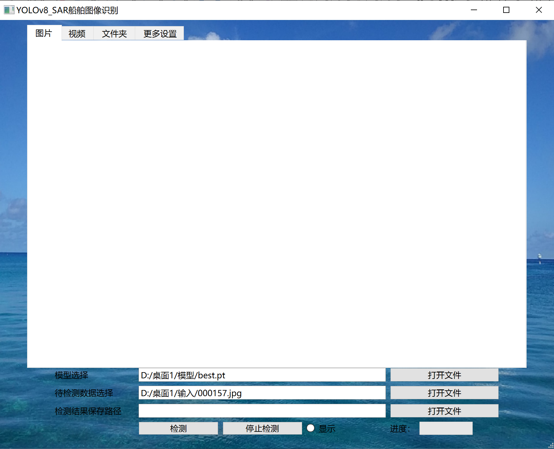

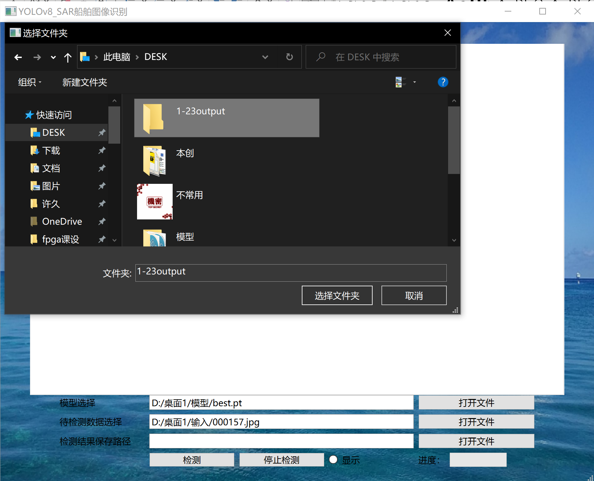

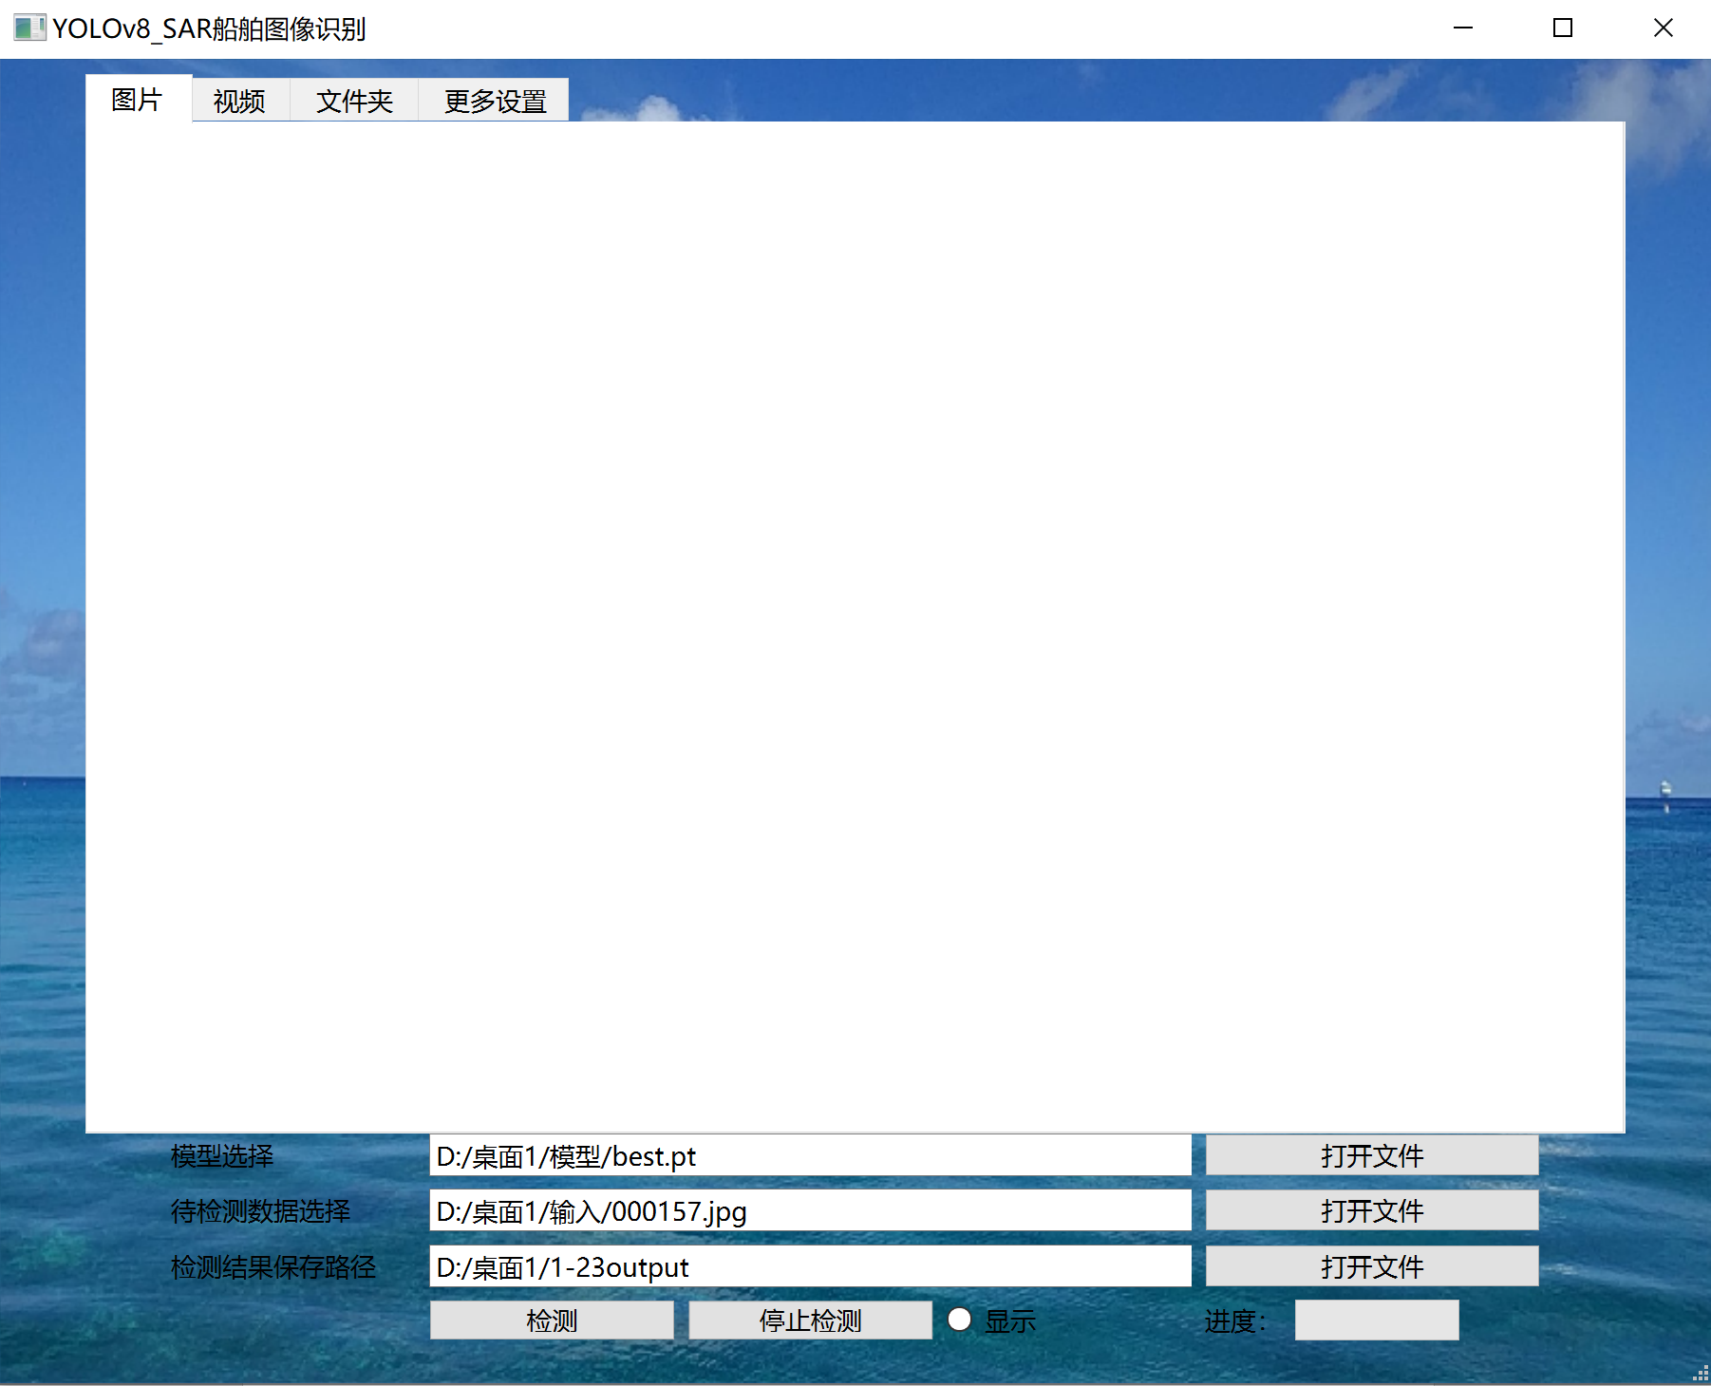

单击‘显示’按钮，实时显示检测结果

单击‘检测’按钮，进行检测

右下角进度条显示检测进度

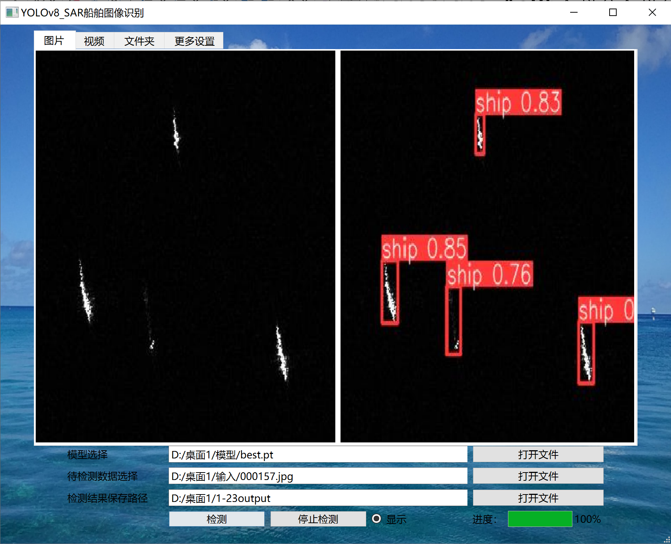

‘视频’检测模式下

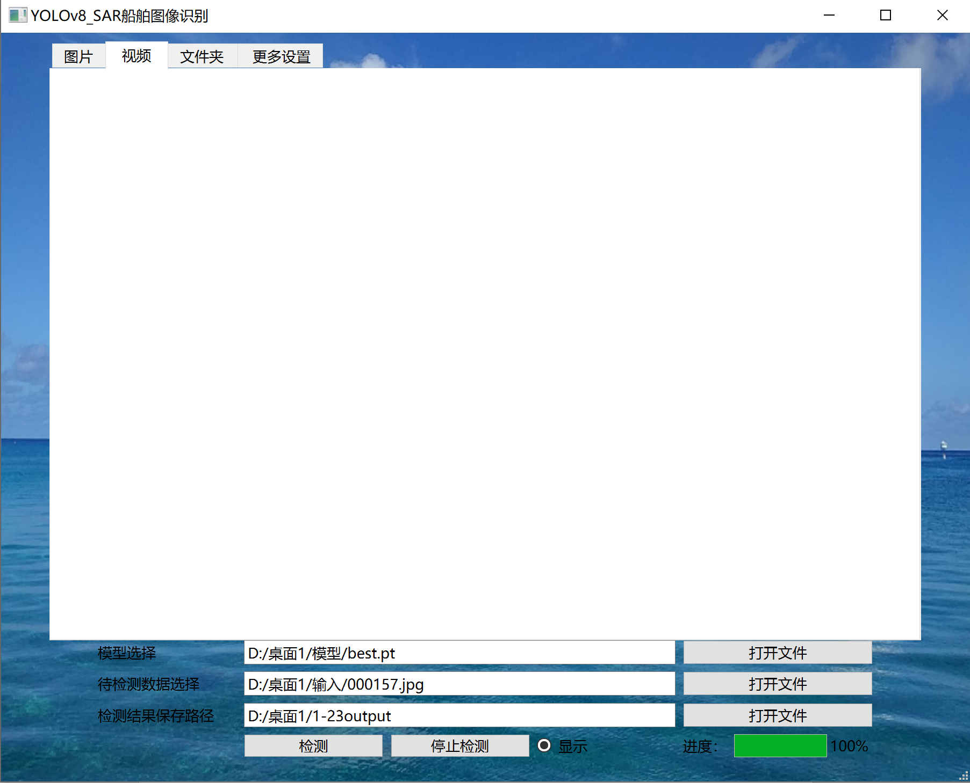

当待监测数据格式与检测模式不匹配（如上图所示：视频页面下，待检测数据为jpg图片格式，），单击‘检测按钮’此时会有弹窗提示错误

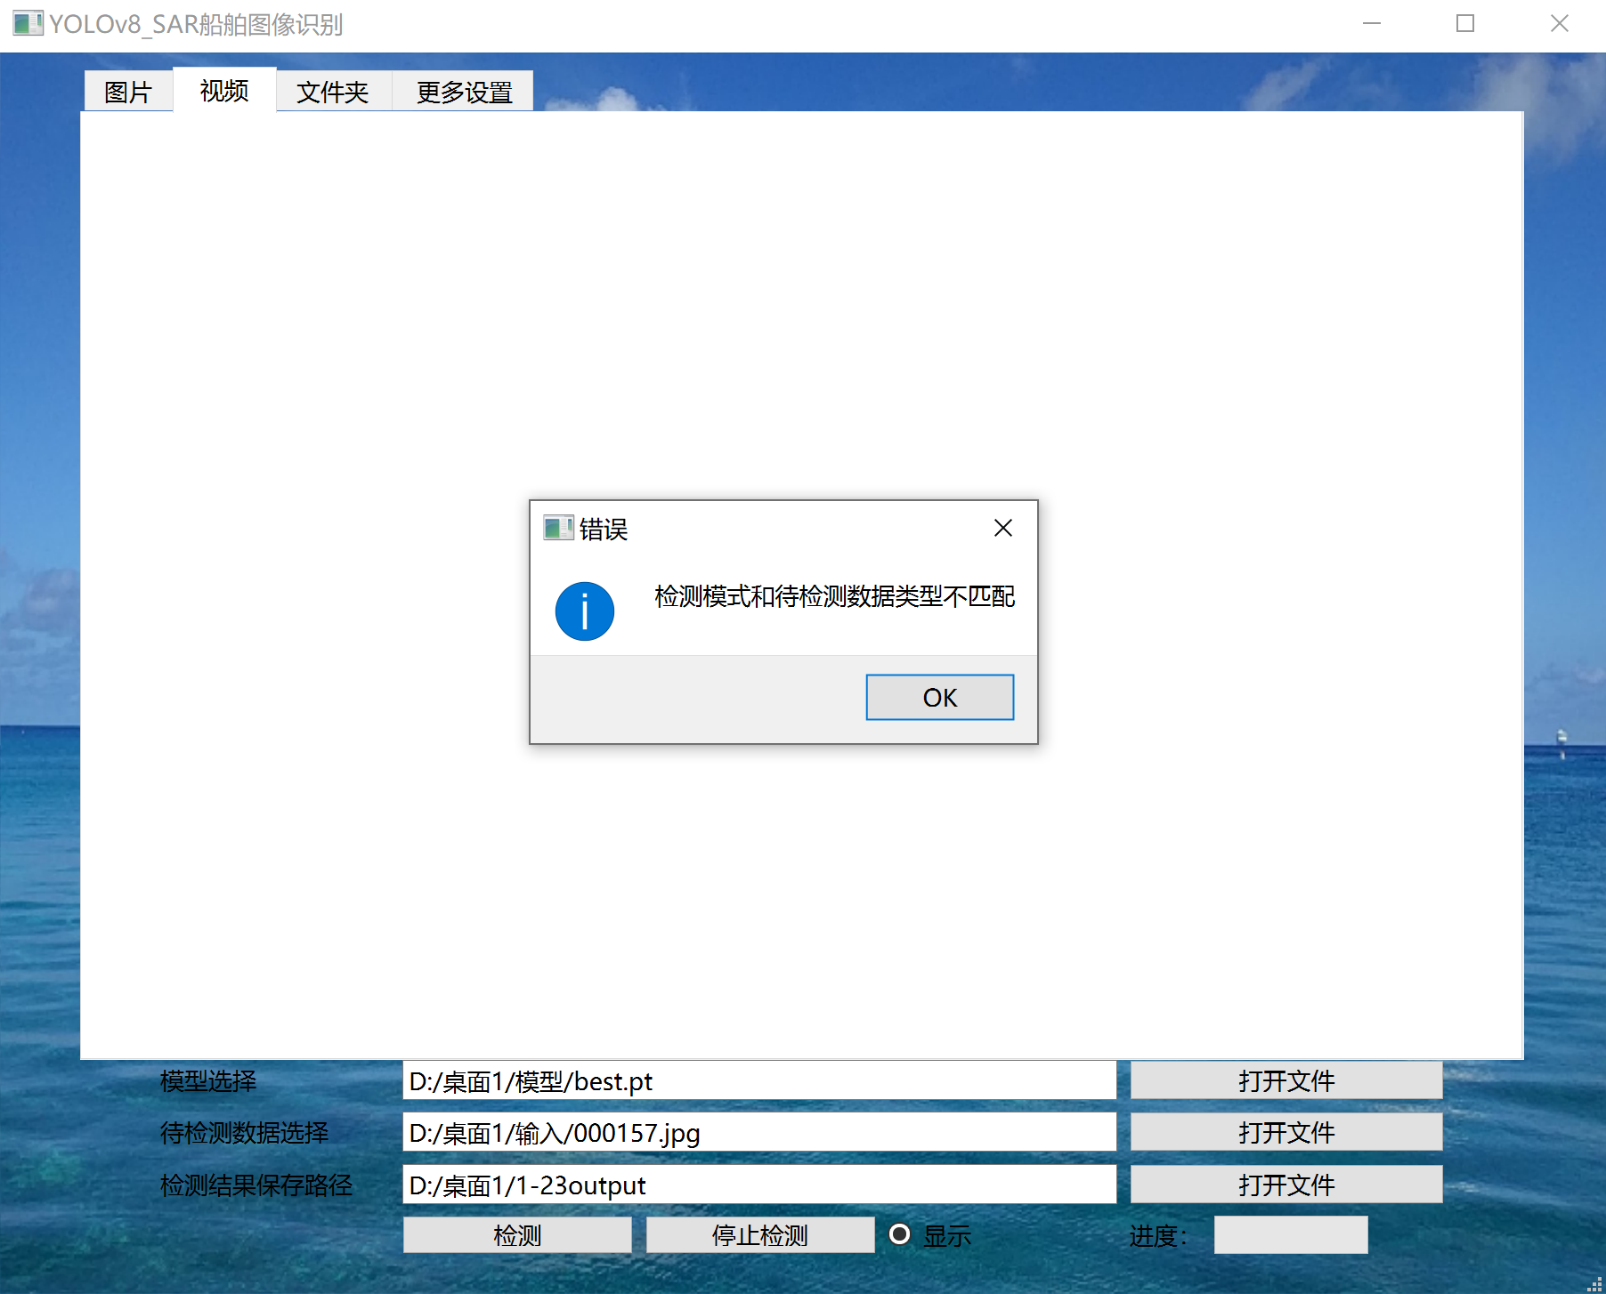

选择视频文件

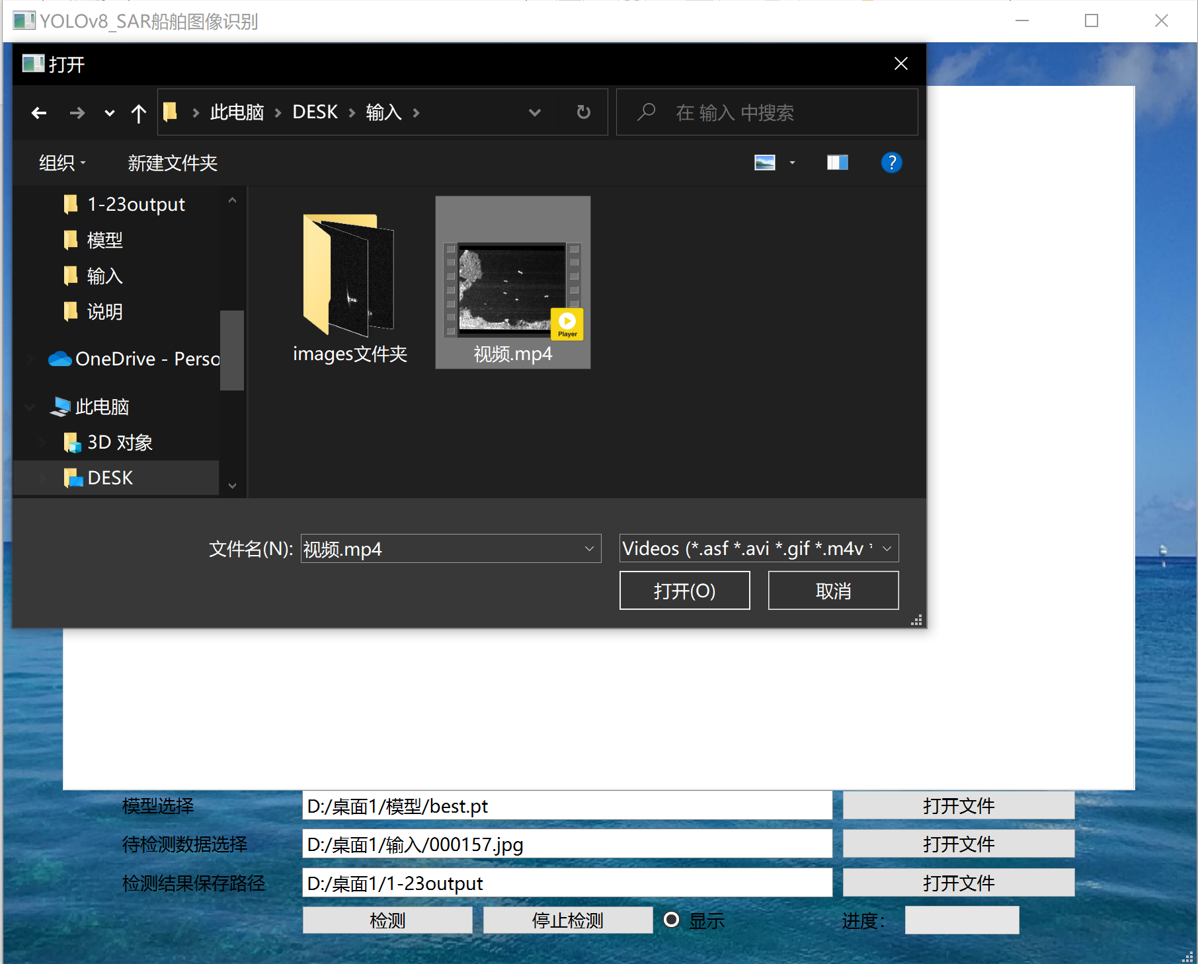

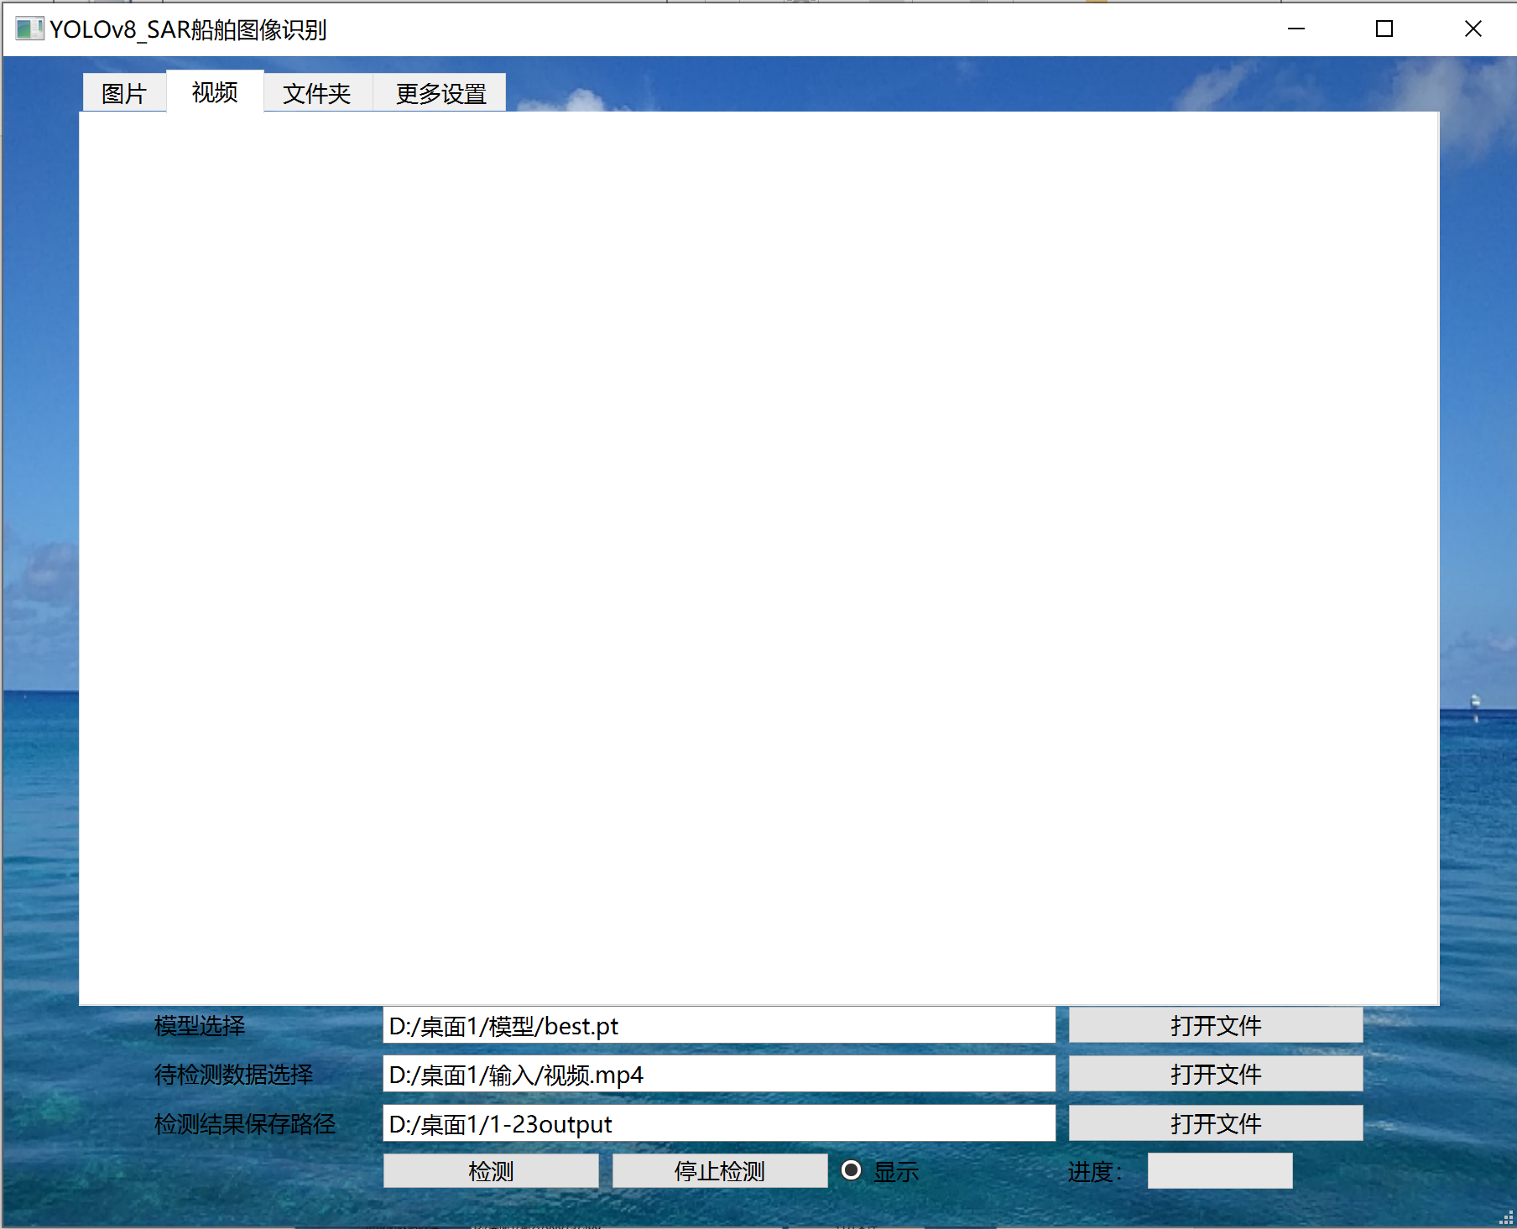

单击‘检测’按钮，进行检测

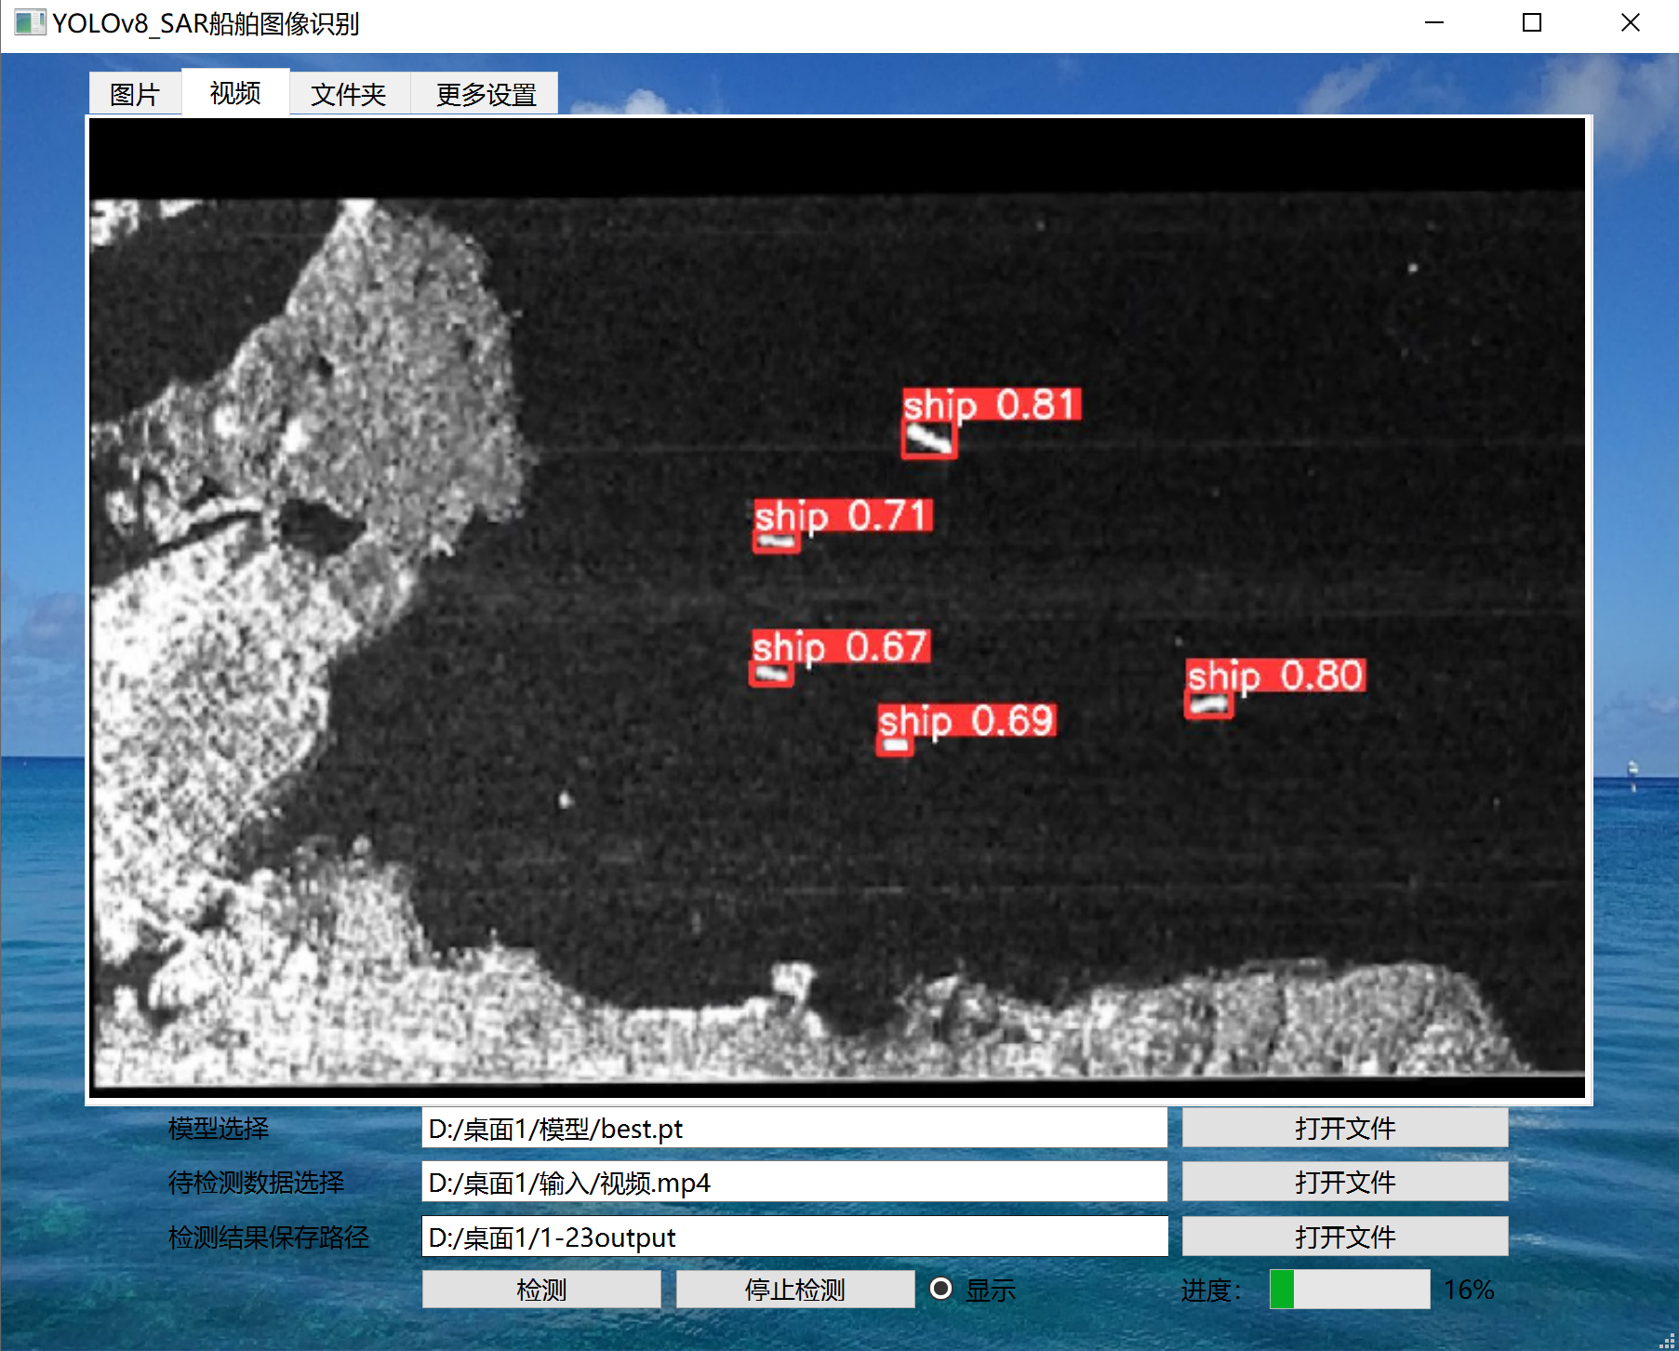

单击‘停止检测’按钮可以停止检测

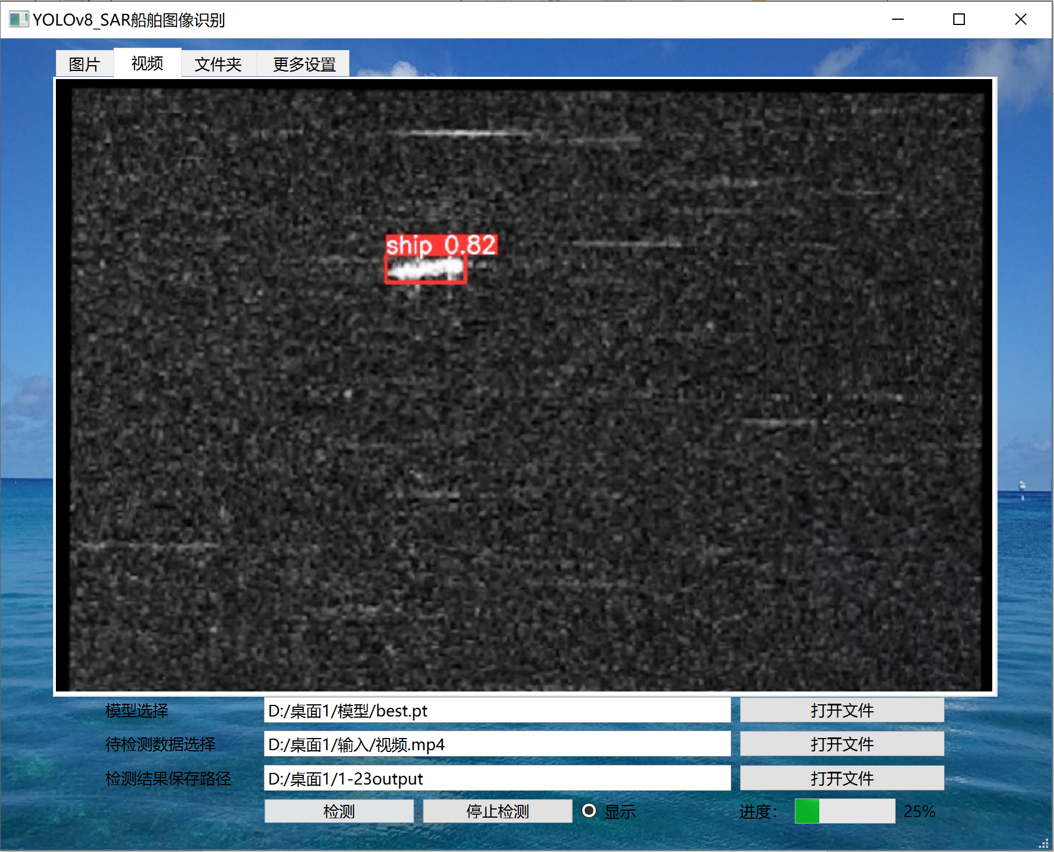

在‘文件夹’检测模式下

选择待检测数据文件夹

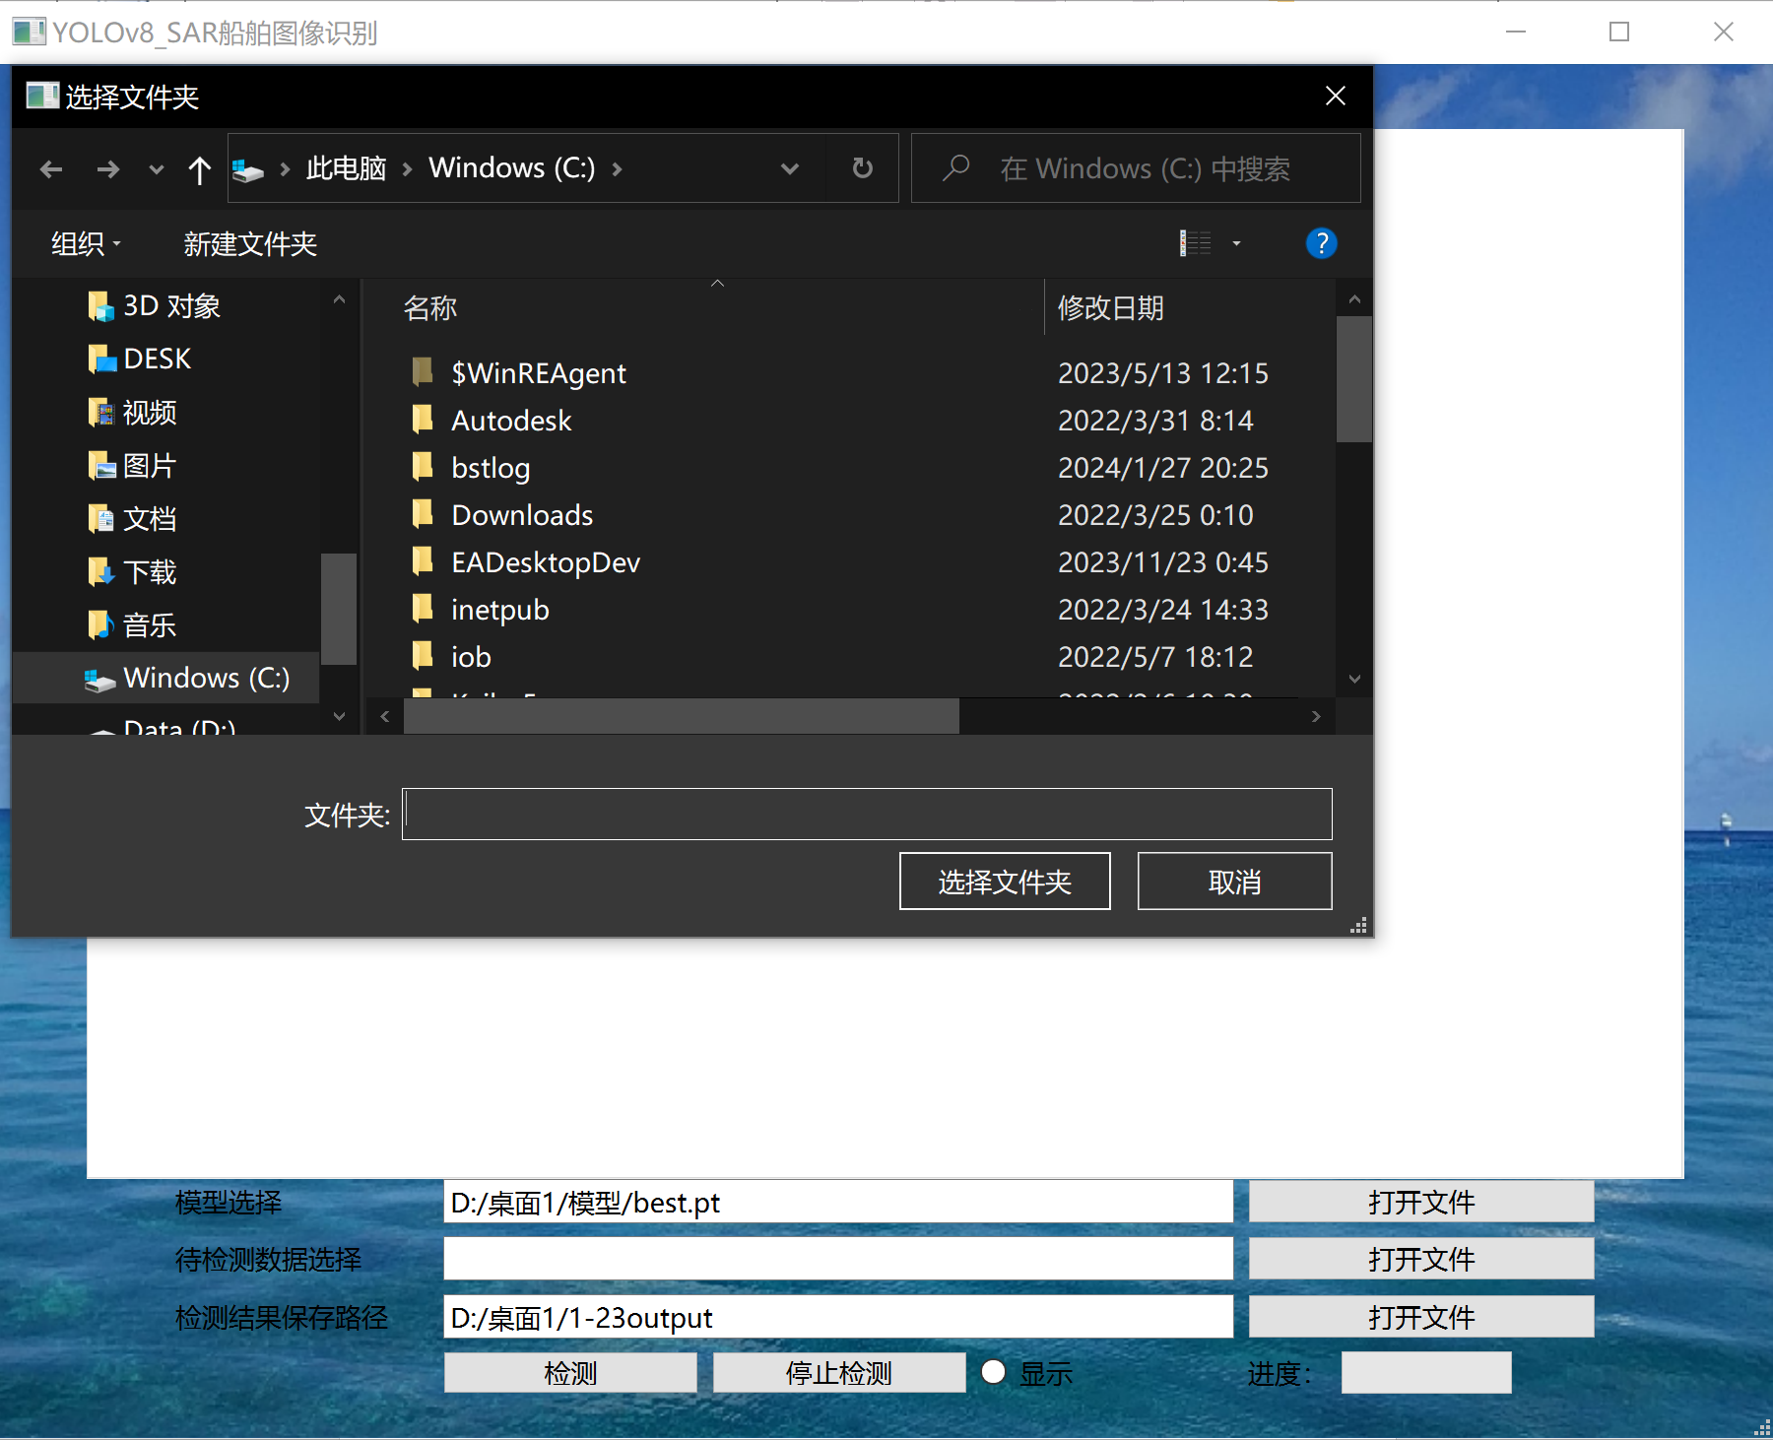

单击‘检测’按钮进行检测

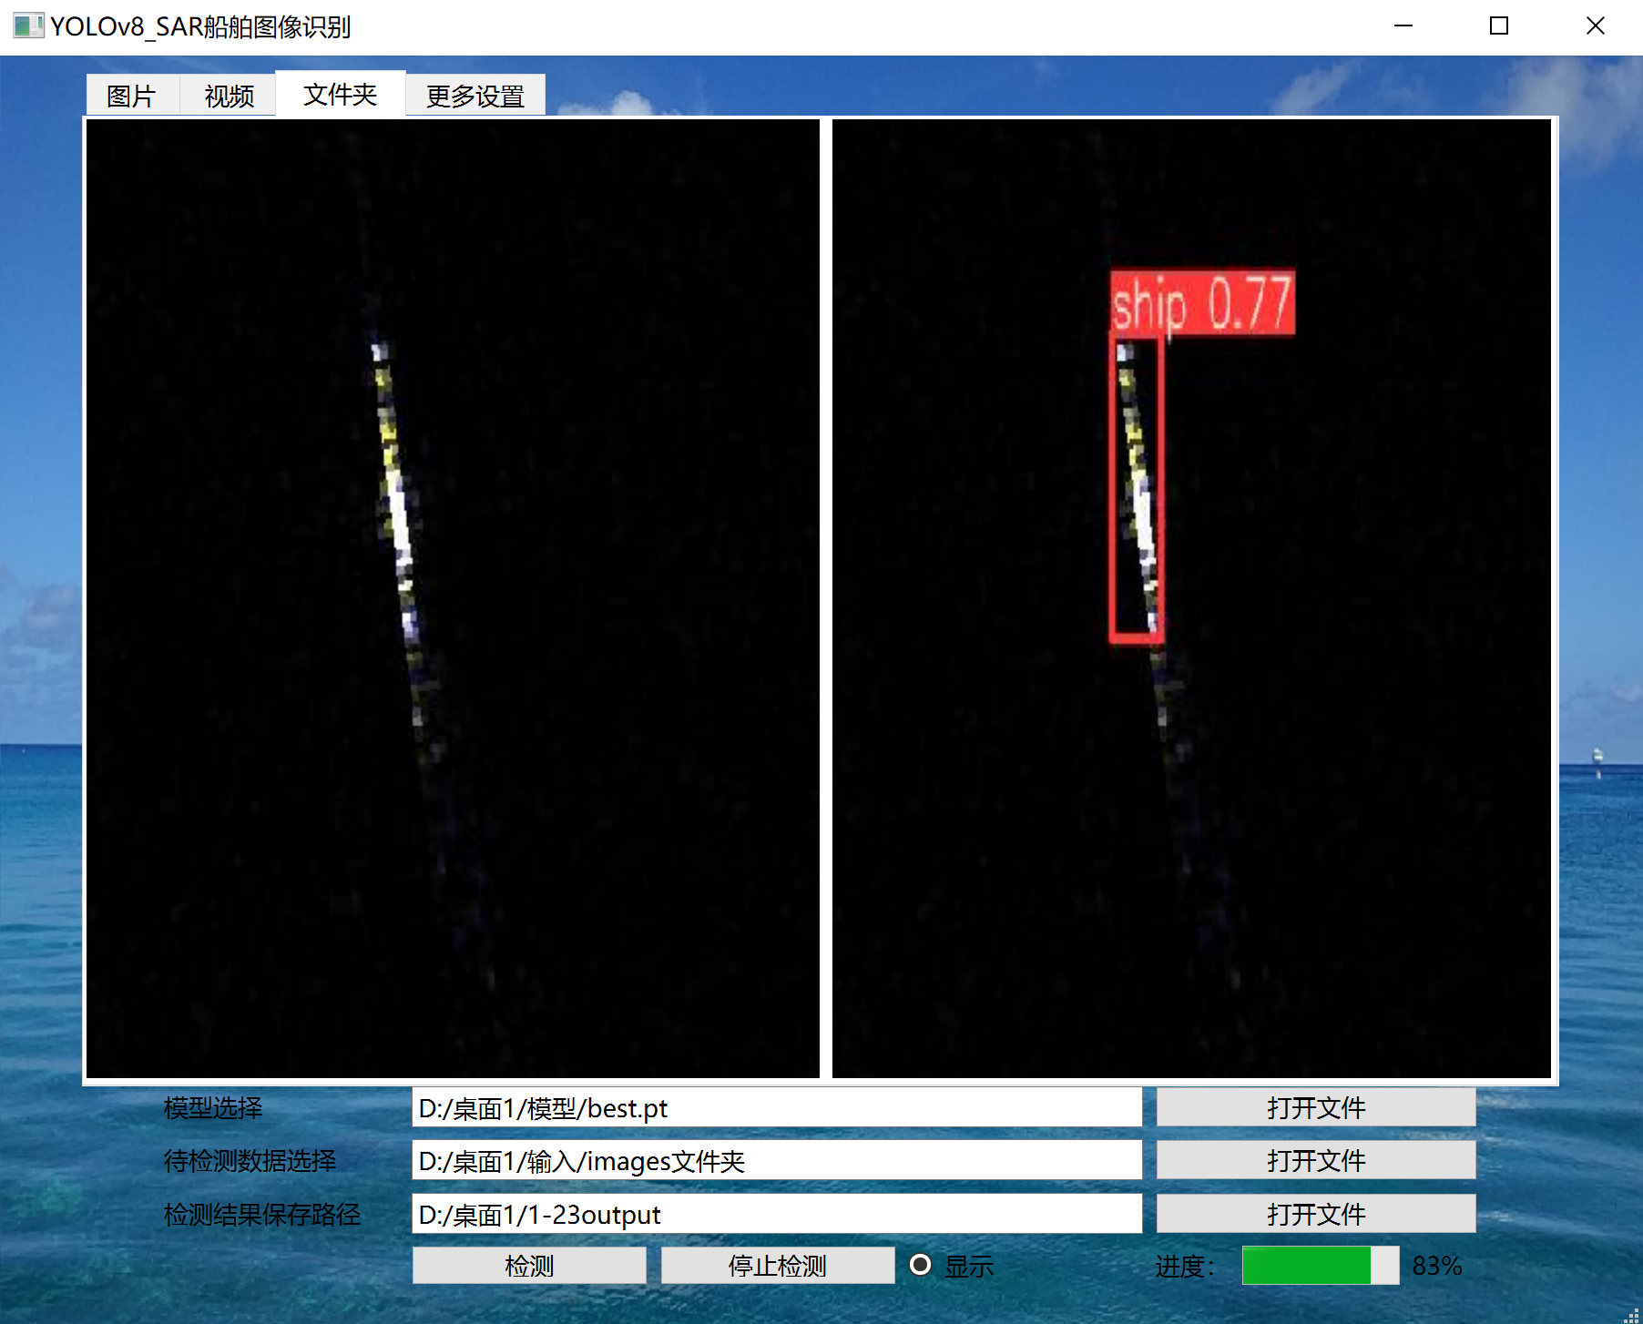

检测完成后右下角进度条会显示100%

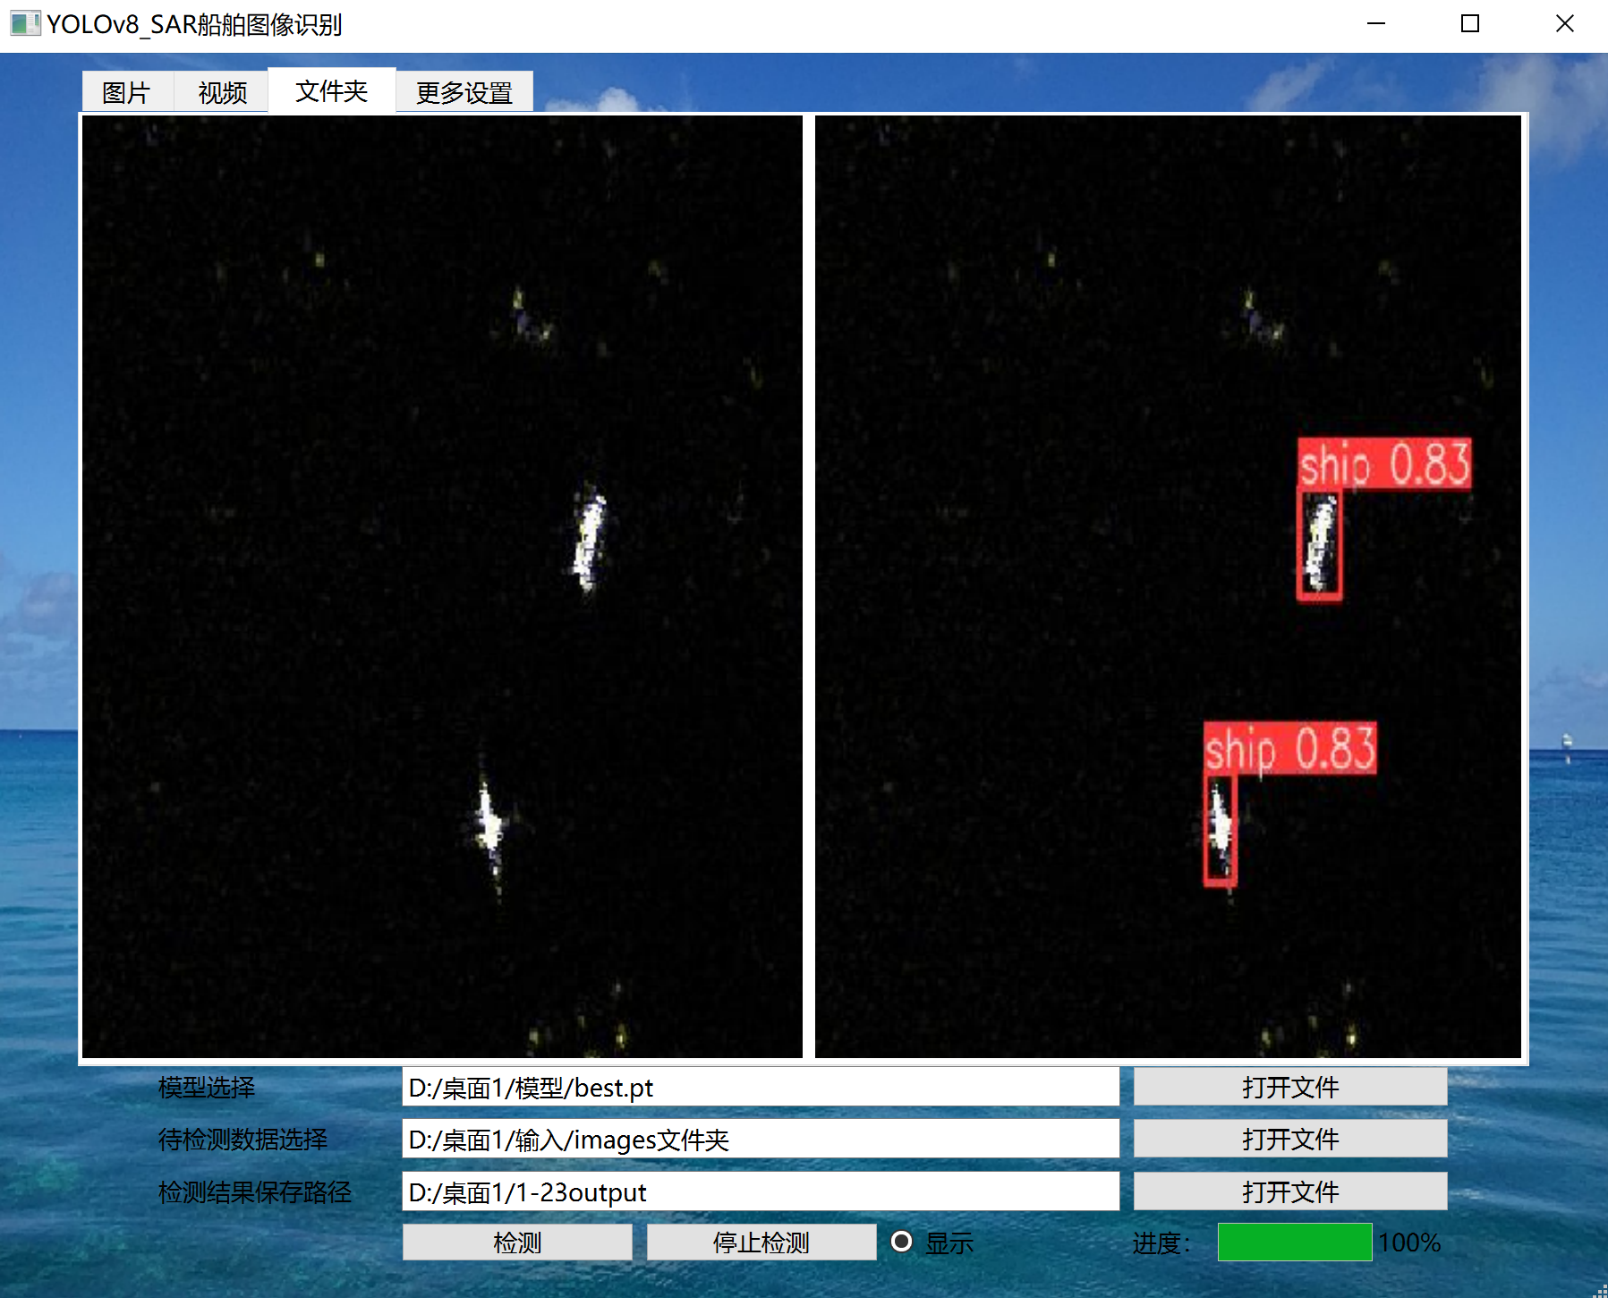

‘更多设置’一栏，有iou，conf，save_txt，save_conf，save_crop参数的调整入口

iou：默认0.7,取值范围：0~1 NMS 的交集并集 （IoU） 阈值

conf：默认0.25,取值范围：0~1 检测的对象置信度阈值

save_txt：默认False，取值范围True/False 将结果（类别，位置）另存为 .txt 文件

save_conf：默认False，取值范围True/False 将置信度分数保存入结果

save_crop：默认False，取值范围True/False 保存带有结果的裁剪图像

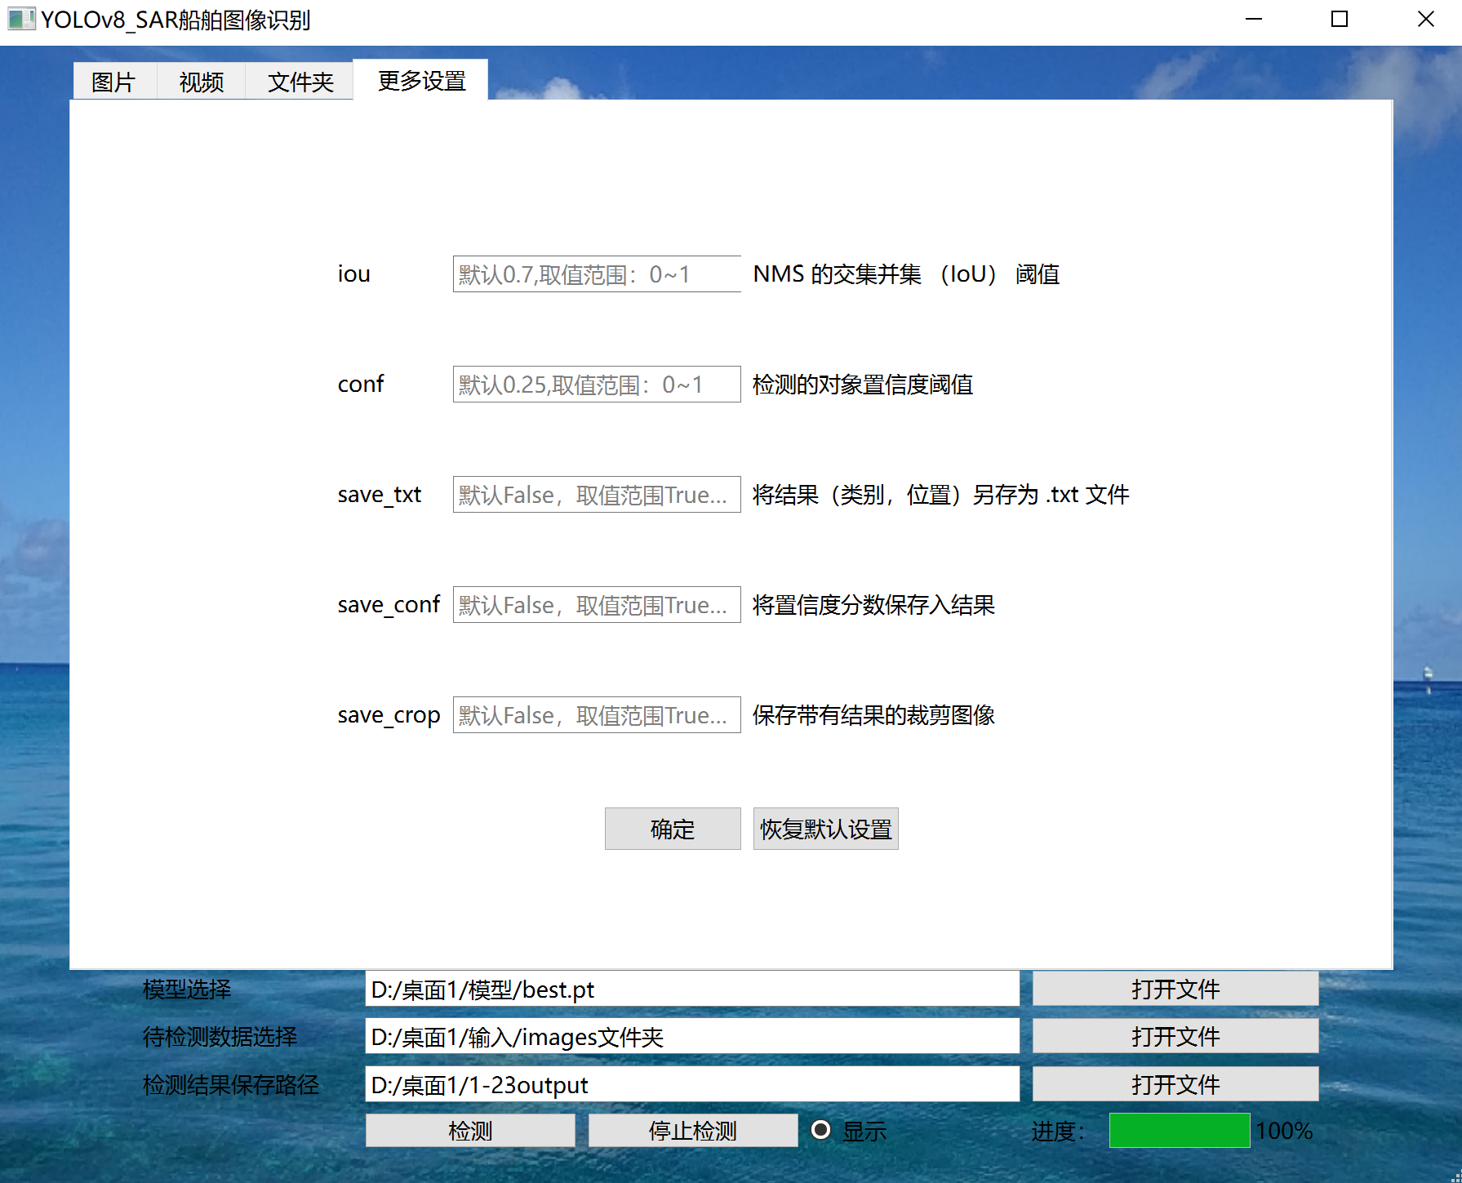

更改设置：在相应文本框内输入需要更改的值，然后单击‘确定’按钮保存并应用新设置

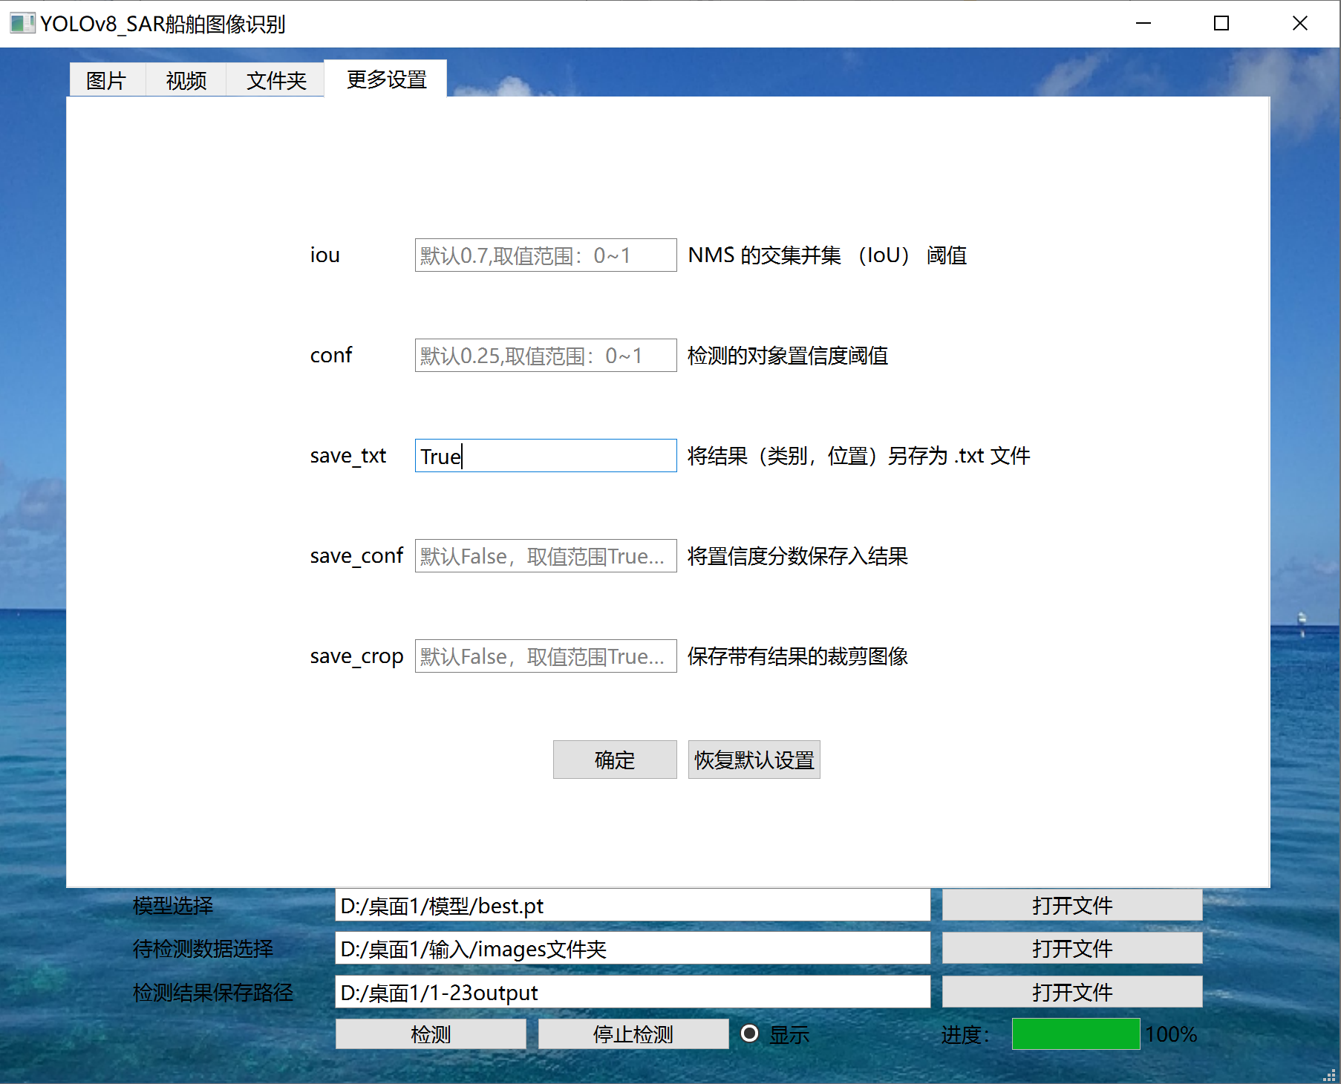

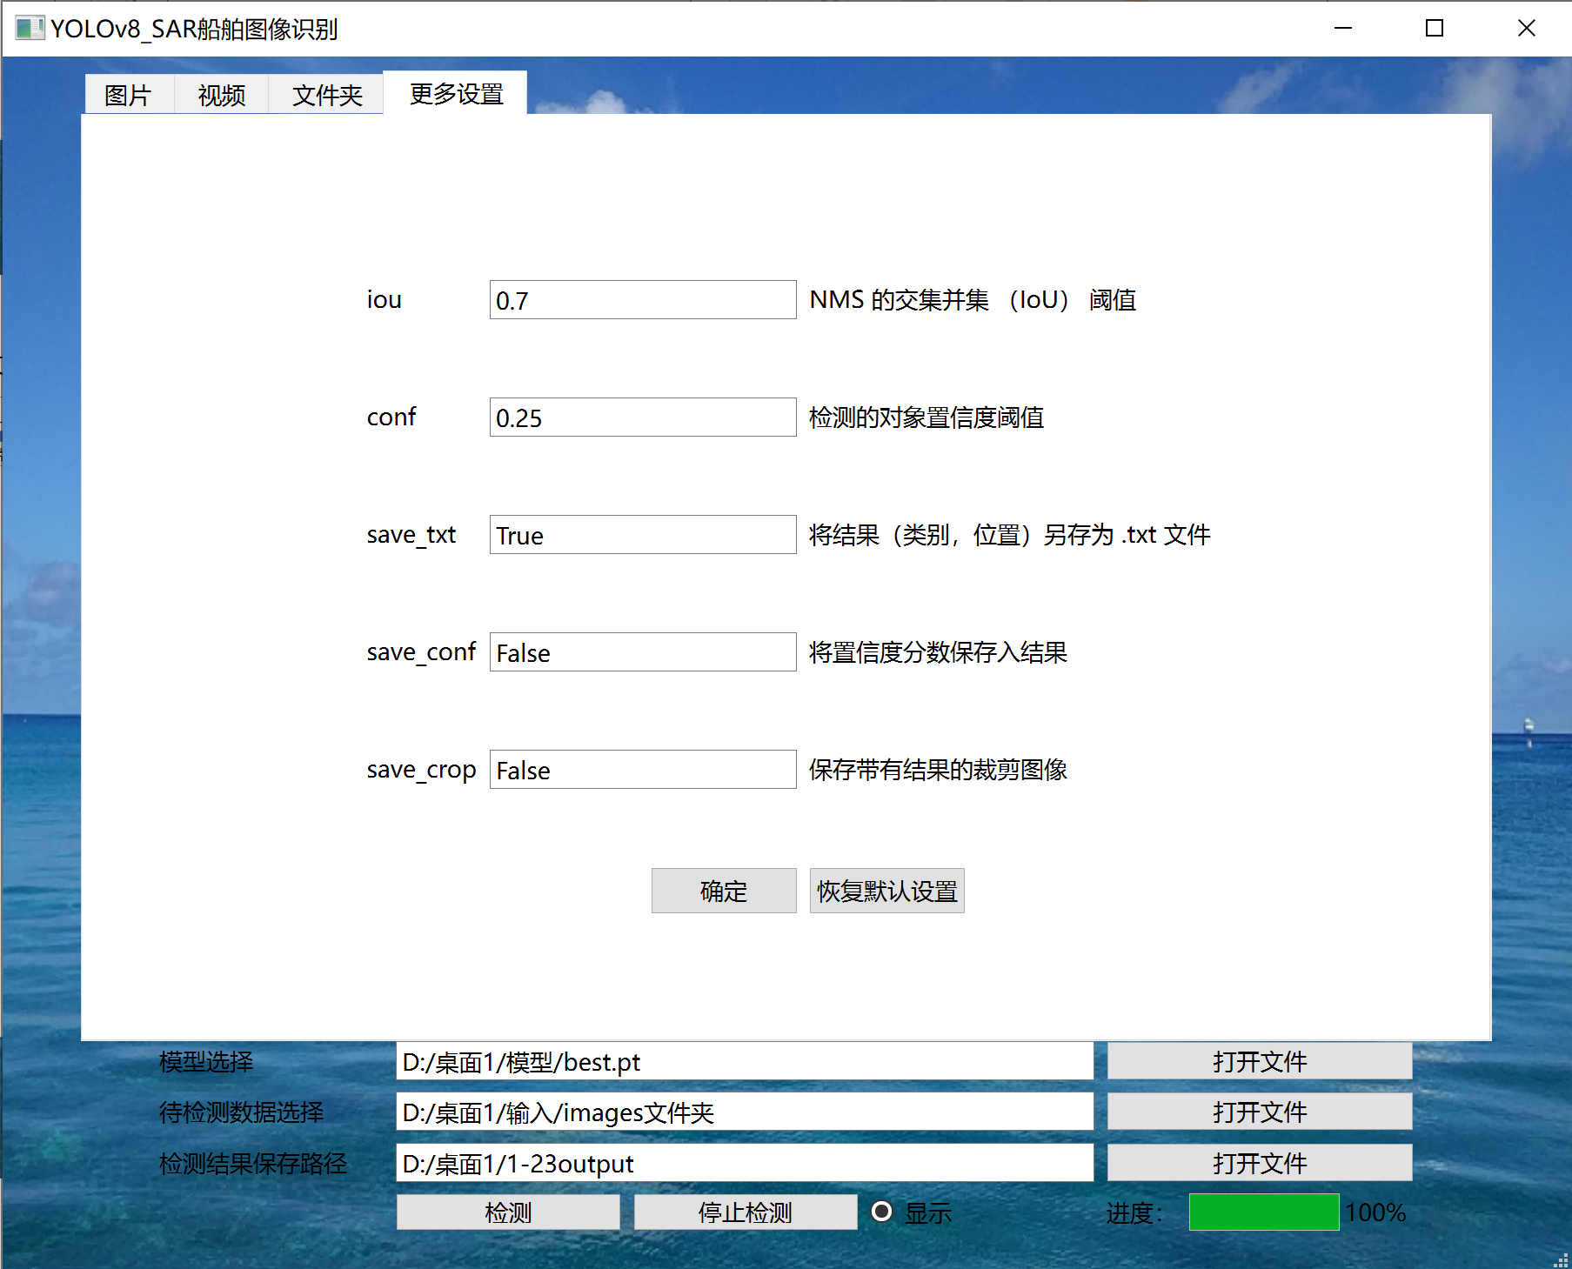

单击‘恢复默认设置’按钮可一键恢复

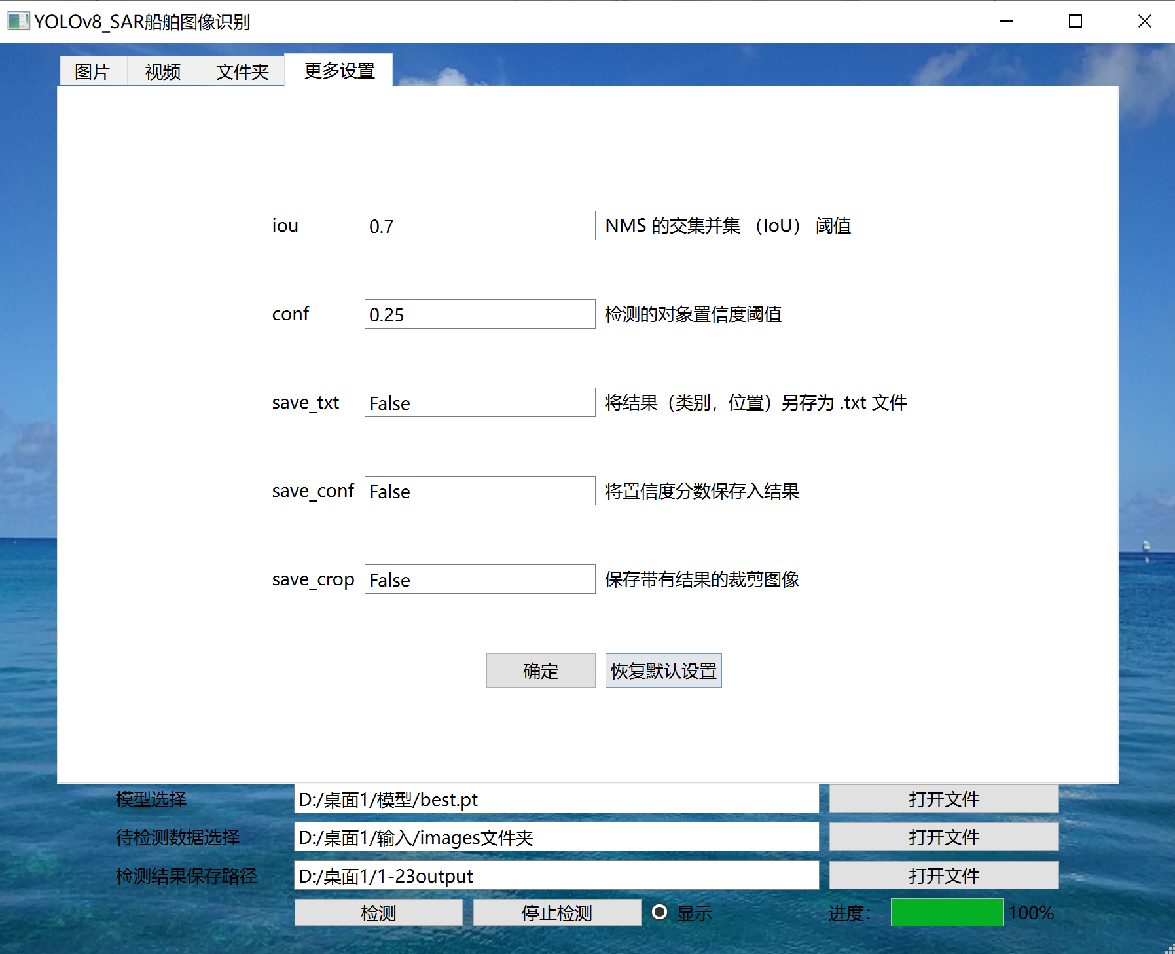

在默认设置下

图片，视频，文件夹保存形式为

图片检测结果与原图命名一致，直接保存在指定文件夹内

视频检测结果以 （***_video,***表示原视频名） 格式作为新命名，保存在指定文件夹内

文件夹检测结果与原文件夹命名一致，每个检测文件命名也与原文件保持一致，直接保存在指定文件夹内

示例：

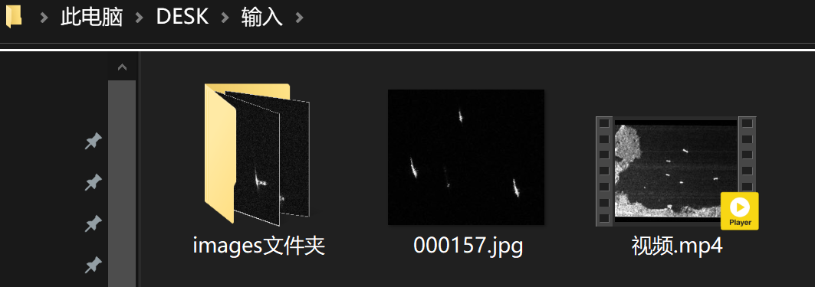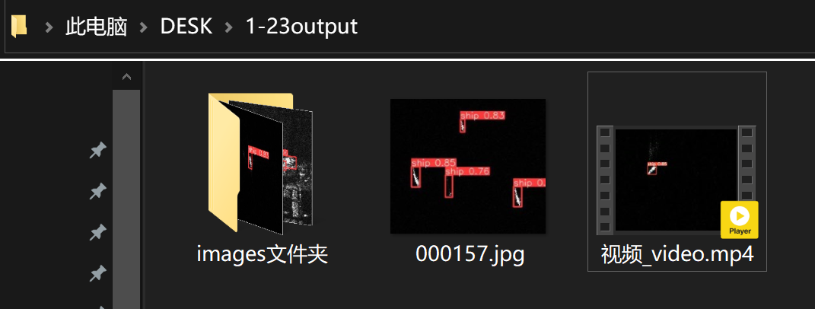

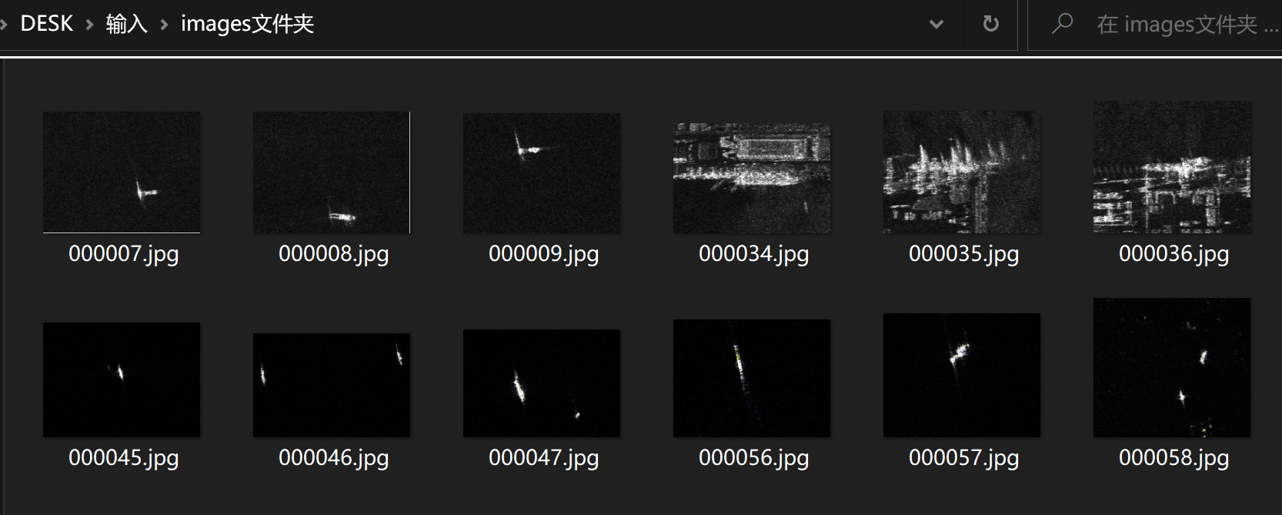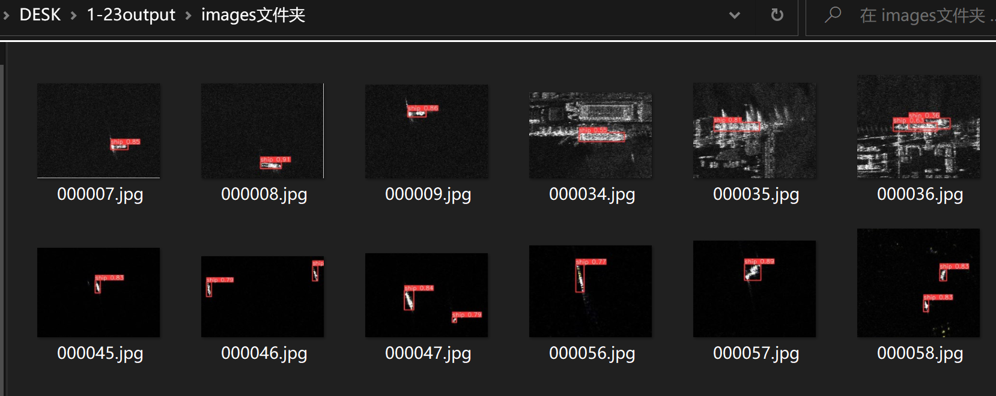

在更改设置save_txt=True下

图片，视频，文件夹保存形式为

在指定文件夹内新建与原文件名一致的文件夹，其中包含检测结果图片/视频以及labels文件夹下txt文件

示例：

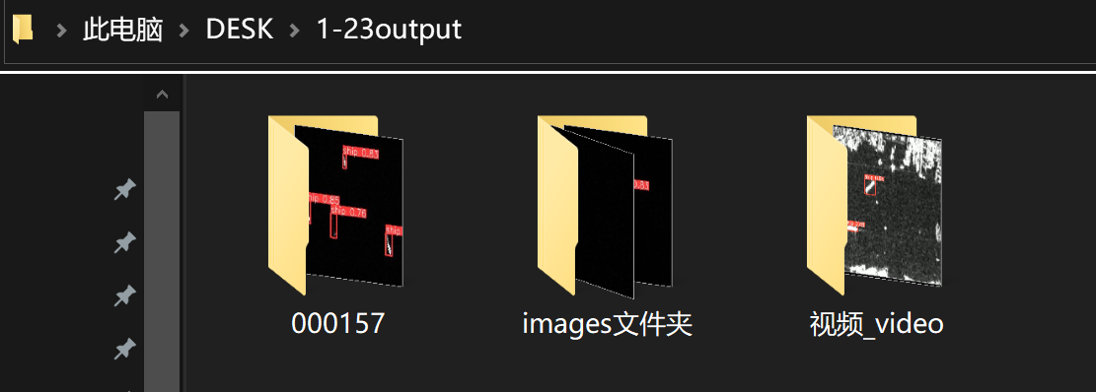

图片检测结果文件夹

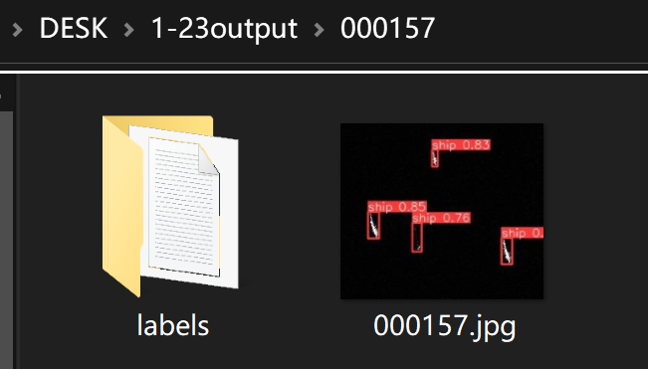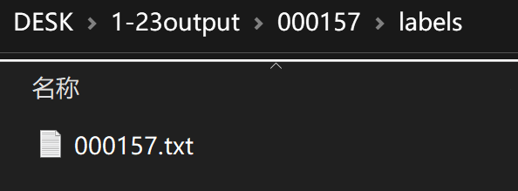

视频检测结果文件夹

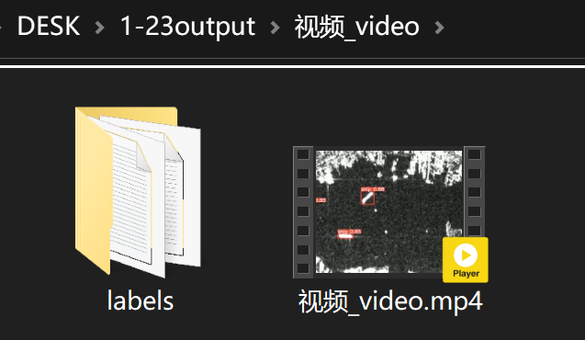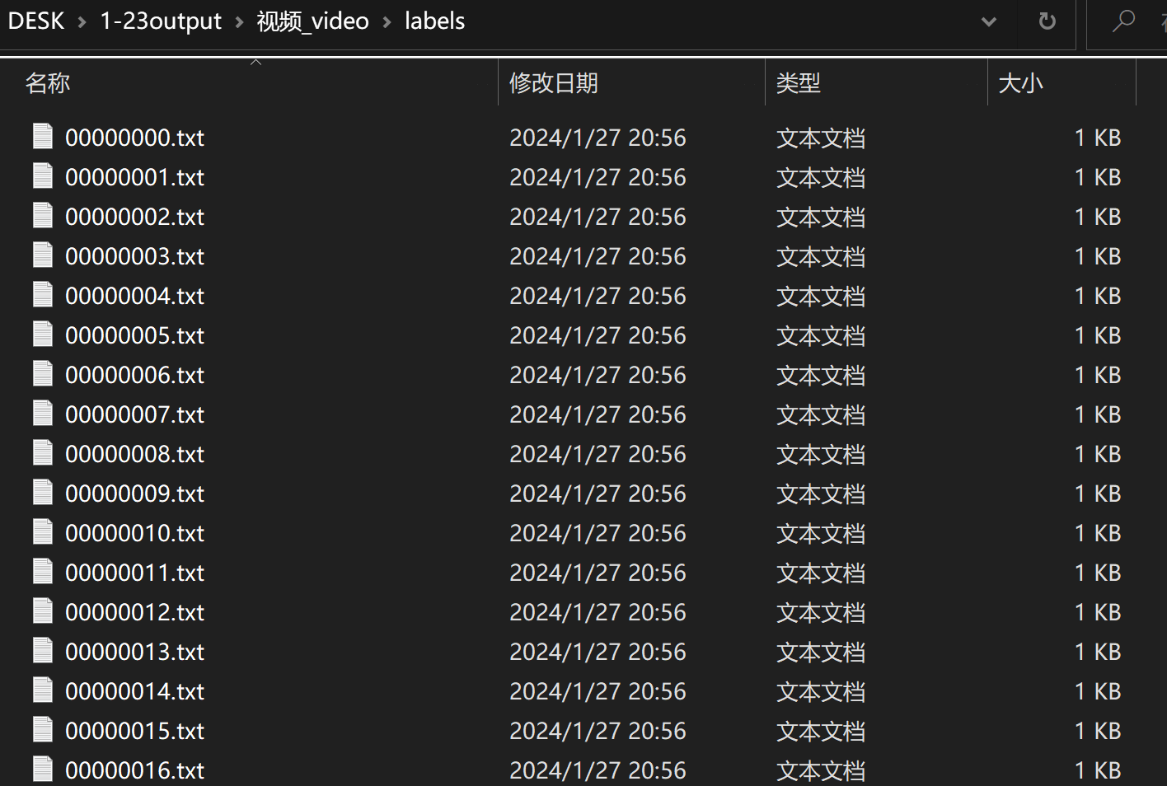

labels文件夹内为视频每一帧的类别，位置数据

文件夹检测结果

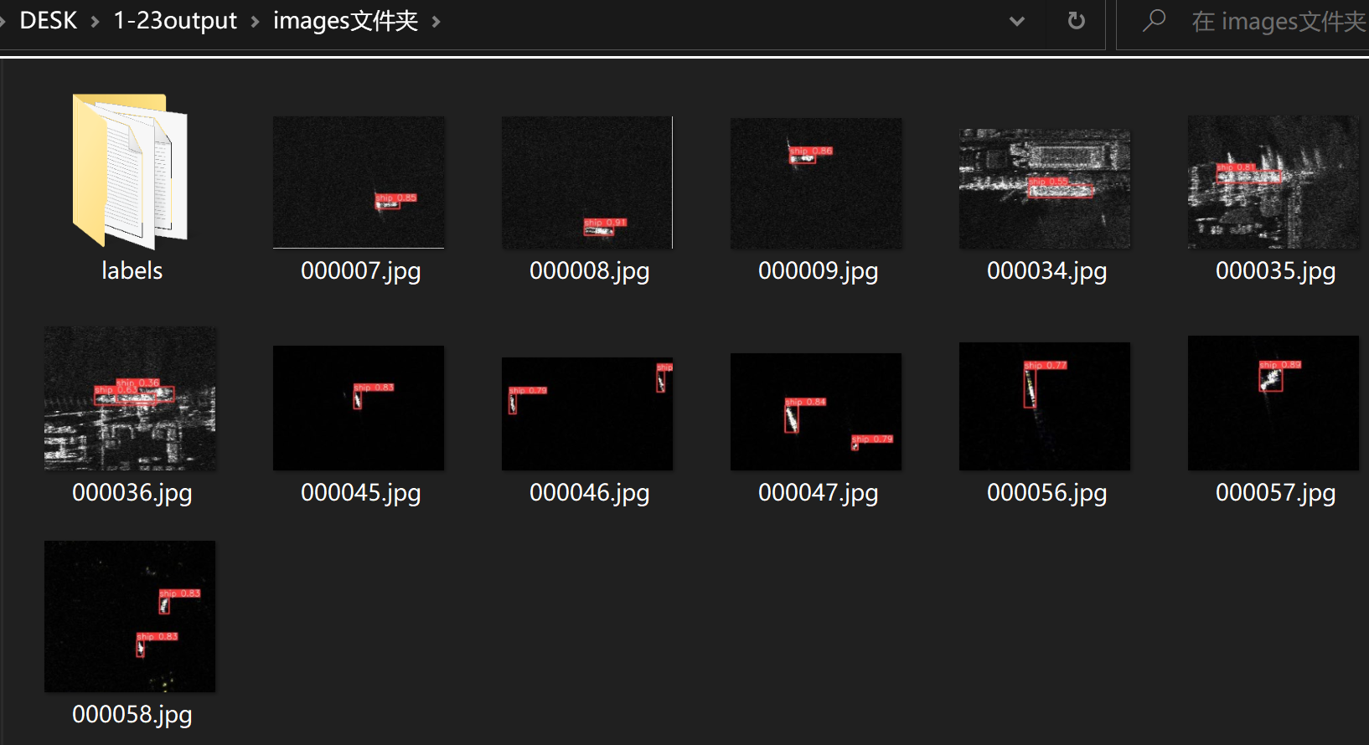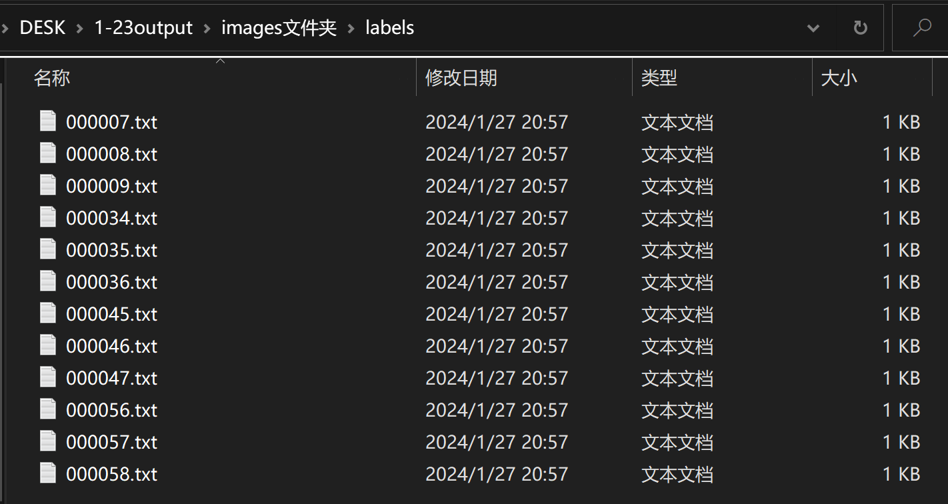

在更改设置save_crop=True下

保存格式与save_txt=True相同,crops内保存的是检测到的船舶区域裁剪图像

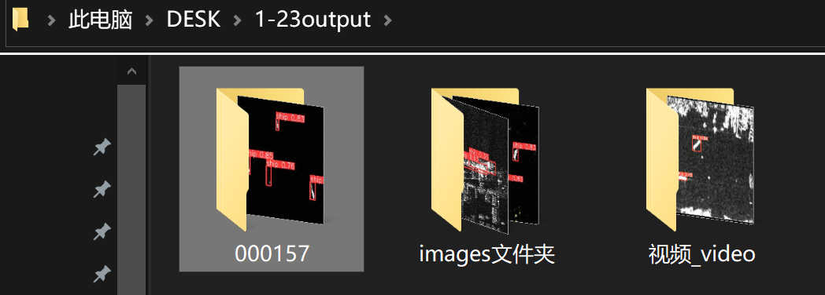

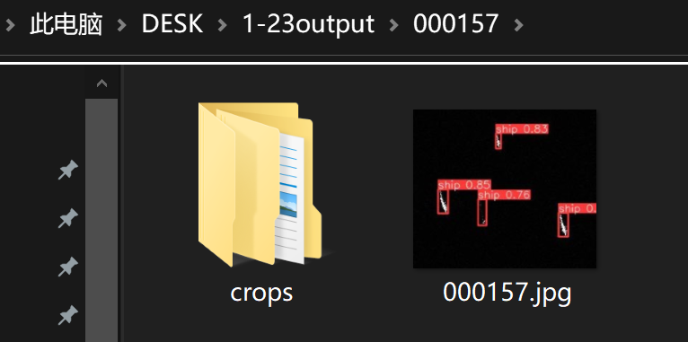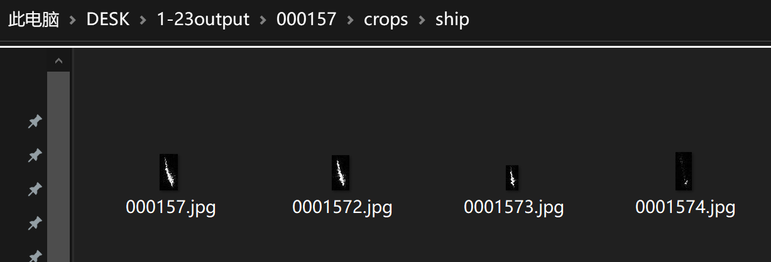

‘显示.py’ 文件代码如下

import os  
import shutil  
  
import cv2  
from PIL import Image  
from PyQt6.QtCore import Qt**,** QTimer  
from PyQt6.QtGui import QPixmap**,** QPixmapCache**,** QBrush**,** QResizeEvent  
from PyQt6.QtWidgets import QApplication**,** QLineEdit**,** QPushButton**,** QRadioButton**,** QFileDialog**,** QLabel**,** QTabWidget**,** \  
 QWidget**,** QGridLayout**,** QMessageBox**,** QProgressBar  
from PyQt6 import uic  
import sys  
from ultralytics import YOLO  
  
  
def pre(in_model_path**,** in_images_path**,** out_path):  
 progressBar.reset()  
 current_index = tabWidget.currentIndex()  
 print(current_index)  
 global stop  
 global iou**,** conf**,** save_txt**,** save_conf**,** save_crop**,** exist_ok  
 global pixmap0**,** pixmap1**,** pixmap2**,** pixmap3**,** pixmap4  
 stop = False  
 if in_model_path == '':  
 lineEdit.setText(lineEdit.placeholderText())  
 in_model_path = lineEdit.placeholderText()  
 if in_images_path == '':  
 lineEdit_2.setText(lineEdit_2.placeholderText())  
 in_images_path = lineEdit_2.placeholderText()  
 if out_path == '':  
 lineEdit_3.setText(lineEdit_3.placeholderText())  
 out_path = lineEdit_3.placeholderText()  
 if current_index == **0**:  
 # 图片被保存在这个路径  
 output_name = in_images_path.split('/')  
 output_name = output_name[-**1**] # 不带路径的纯文件名字，例 000006.jpg  
 suffix=['bmp' **,**'dng' **,**'jpeg' **,**'jpg'**,** 'mpo' **,**'png'**,** 'tif'**,** 'tiff' **,**'webp'**,** 'pfm']  
 suffix_ok=False  
 if '.'in output_name:  
 output_name_suffix=output_name.split('.')[**1**]  
 print('output_name_suffix'**,**output_name_suffix)  
 for suffix_one in suffix:  
 if output_name_suffix ==suffix_one:  
 suffix_ok=True  
 if suffix_ok ==False:  
 error_message()  
 return **0** print('output_name'**,** output_name)  
  
 model = YOLO(in_model_path)  
 if save_txt or save_crop:  
 name = output_name.split('.')[**0**]  
 name = f'{out_path}/{name}' # 如果额外保存txt文件就不能直接在输出文件夹内放入图片，要新建个文件夹放图片及txt  
 results = model(in_images_path**,** iou=iou**,** save_txt=save_txt**,** save_conf=save_conf**,** name=name**,** exist_ok=exist_ok**,** save_crop=save_crop**,** conf=conf**,** show=False)  
 else:  
 results = model(in_images_path**,** iou=iou**,** exist_ok=exist_ok**,** conf=conf**,** show=False)  
  
 for r in results:  
 im_array = r.plot() # plot a BGR numpy array of predictions  
 im = Image.fromarray(im_array[...**,** ::-**1**]) # RGB PIL image  
 if save_txt or save_crop:  
 name = output_name.split('.')[**0**]  
 name = f'{out_path}/{name}'  
 output = f'{name}/{output_name}'  
 else:  
 output = f'{out_path}/{output_name}'  
 im.save(output) # save image with new name  
 progressBar_work(**100**) # 更新进度条  
 if show_value:  
 # print('之前',pixmap3)  
 pixmap3 = QPixmap(in_images_path)  
 print('之后'**,** pixmap3)  
 pixmap3 = pixmap3.scaled(label_8.width()**,** label_8.height())  
 label_8.setPixmap(pixmap3)  
 # 创建一个QPixmap对象并加载图片  
 pixmap4 = QPixmap(output)  
 pixmap4 = pixmap4.scaled(label_7.width()**,** label_7.height())  
 # 将图片设置到label_3中  
 label_7.setPixmap(pixmap4)  
 if current_index == **1**: # 第二页对应读取视频模式  
 output_name = in_images_path.split('/')  
 output_name = output_name[-**1**]  
 suffix = ['asf' **,**'avi' **,**'gif'**,**'m4v' **,**'mkv' **,**'mov' **,**'mp4'**,**'mpeg' **,**'mpg' **,**'ts' **,**'wmv' **,**'webm']  
 suffix_ok = False  
 if '.' in output_name:  
 output_name_suffix = output_name.split('.')[**1**]  
 print('output_name_suffix'**,** output_name_suffix)  
 for suffix_one in suffix:  
 if output_name_suffix == suffix_one:  
 suffix_ok = True  
 if suffix_ok == False:  
 error_message()  
 return **0** cap = cv2.VideoCapture(in_images_path)  
 total_frames = int(cap.get(cv2.CAP_PROP_FRAME_COUNT))  
 print('total_frames'**,**total_frames)  
 model = YOLO(in_model_path)  
 i = **0** output_name = output_name.split('.')[**0**]  
 output_name = f'{output_name}_video' # 防止输入视频名为全数字和文件整理函数冲突造成误删崩溃  
 output_dir = f'{out_path}/{output_name}'  
  
 print('输出视频结果地址'**,** output_dir)  
 if save_txt or save_crop:  
 output_img_dir = f'{output_dir}/{output_name}' # 视频帧临时保存文件夹  
 else:  
 output_img_dir = output_dir  
 os.makedirs(output_img_dir**,** exist_ok=True)  
  
 while cap.isOpened():  
  
 i_long = str(i).zfill(**8**)  
 name = f'{output_dir}/{i_long}' # 如果额外保存txt文件就不能直接在输出文件夹内放入图片，要新建个文件夹放图片及txt  
 output = f'{output_img_dir}/{i_long}.jpg' # 视频帧  
 ret**,** frame = cap.read()  
 if not ret:  
 break  
 if save_txt or save_crop:  
  
 print('name'**,** name)  
 results = model(frame**,** iou=iou**,** save_txt=save_txt**,** save_conf=save_conf**,** name=name**,** save_crop=save_crop**,** conf=conf**,** exist_ok=exist_ok**,** show=False)  
 print('保存txt路径'**,** name)  
 else:  
 results = model(frame**,** iou=iou**,** conf=conf**,** exist_ok=exist_ok**,** show=False)  
  
 for r in results:  
 im_array = r.plot() # plot a BGR numpy array of predictions  
 im = Image.fromarray(im_array[...**,** ::-**1**]) # RGB PIL image  
  
 im.save(output) # save image with new name  
 if show_value:  
 QPixmapCache.clear()  
 pixmap2 = QPixmap(output)  
 pixmap2 = pixmap2.scaled(label_6.width()**,** label_6.height())  
 # 将图片设置到label_6中  
 label_6.setPixmap(pixmap2)  
 i = i + **1** if cv2.waitKey(**1**) & **0xff** == ord('q'):  
 break  
 if stop:  
 break  
 progressBar_work(int(i * **100** / total_frames))  
 cap.release()  
 cv2.destroyAllWindows()  
 save_video(output_img_dir)  
 file_ordering(output_dir**,** save_txt=save_txt**,** save_crop=save_crop)  
 if current_index == **2**: # 第三页对应读取文件夹模式，文件夹只能有图片  
 output_name = in_images_path.split('/')  
 output_name = output_name[-**1**] # 纯输出文件夹名  
 suffix_ok = True  
 if '.' in output_name:  
 suffix_ok = False  
 if suffix_ok == False:  
 error_message()  
 return **0** filenames = os.listdir(in_images_path)  
 print(f'"输入文件夹："{in_images_path}')  
  
  
 output_dir = f'{out_path}/{output_name}' # 输出文件夹路径  
 os.makedirs(output_dir**,** exist_ok=True)  
 print('output_dir'**,** output_dir)  
  
 model = YOLO(in_model_path)  
 i=**0** for one_image in filenames:  
 if stop:  
 break  
 file_count = len(filenames)  
  
 in_img = f'{in_images_path}/{one_image}' # 单个图片输入地址  
  
 if save_txt or save_crop:  
 one_image_name = one_image.split('.')[**0**]  
 name = f'{output_dir}/{one_image_name}'  
 results = model(in_img**,** iou=iou**,** save_txt=save_txt**,** save_conf=save_conf**,** name=name**,** save_crop=save_crop**,** conf=conf**,** exist_ok=exist_ok**,** show=False)  
 print('保存txt路径'**,** name)  
 else:  
 results = model(in_img**,** iou=iou**,** conf=conf**,** exist_ok=exist_ok**,** show=False)  
 for r in results:  
 im_array = r.plot() # plot a BGR numpy array of predictions  
 im = Image.fromarray(im_array[...**,** ::-**1**]) # RGB PIL image  
 # 图片被保存在这个路径  
 output = f'{output_dir}/{one_image}'  
 im.save(output) # save image with new name  
  
 print(f'"输出",{output}')  
 if show_value:  
 QPixmapCache.clear()  
 pixmap0 = QPixmap(in_img)  
 pixmap0 = pixmap0.scaled(label_3.width()**,** label_3.height())  
 label_3.setPixmap(pixmap0)  
 if cv2.waitKey(**1**) & **0xff** == ord('q'):  
 break  
 # 创建一个QPixmap对象并加载图片  
 QPixmapCache.clear()  
 pixmap1 = QPixmap(output)  
 pixmap1 = pixmap1.scaled(label_5.width()**,** label_5.height())  
 # 将图片设置到label_3中  
 label_5.setPixmap(pixmap1)  
 if cv2.waitKey(**1**) & **0xff** == ord('q'):  
 break  
 i=i+**1** progressBar_work(int(**100** * i / file_count))  
 file_ordering(output_dir**,** save_txt=save_txt**,** save_crop=save_crop)  
  
 if current_index == **4**: # 第一页对应读取文件夹-兼容模式，文件夹里什么都可以有，最后一个只能是图片  
 filenames = os.listdir(in_images_path)  
  
 in_img = f'{in_images_path}/{filenames[-**1**]}' #  
 if show_value:  
 pixmap0 = QPixmap(in_img)  
 pixmap0 = pixmap0.scaled(label_3.width()**,** label_3.height())  
 label_3.setPixmap(pixmap0)  
 print(f'"输入"{in_images_path}')  
 model = YOLO(in_model_path)  
 results = model(in_images_path**,** show=False)  
 i = **0** for r in results:  
 im_array = r.plot() # plot a BGR numpy array of predictions  
 im = Image.fromarray(im_array[...**,** ::-**1**]) # RGB PIL image  
 # 图片被保存在这个路径  
 output = f'{out_path}/{filenames[i]}'  
 im.save(output) # save image with new name  
 i = i + **1** print(f'"输出",{output}')  
 if show_value:  
 # 创建一个QPixmap对象并加载图片  
 pixmap1 = QPixmap(output)  
 pixmap1 = pixmap1.scaled(label_5.width()**,** label_5.height())  
 # 将图片设置到label_3中  
 label_5.setPixmap(pixmap1)  
 if current_index == **3**:  
 c = **0**def file_ordering(path**,** save_txt=False**,** save_crop=False):  
 # 记录需要删除的文件夹路径  
 folders_to_delete = set()  
  
 # 判断是否需要处理 labels 文件夹  
 if save_txt:  
 for root**,** dirs**,** files in os.walk(path):  
 for directory in dirs:  
 if directory.isdigit(): # 检查文件夹名称是否为数字  
 txt_folder_path = os.path.join(root**,** directory**,** 'labels')  
 if os.path.exists(txt_folder_path):  
 # 新建 labels 文件夹并移动 .txt 文件  
 new_labels_folder_path = os.path.join(root**,** 'labels')  
 os.makedirs(new_labels_folder_path**,** exist_ok=True)  
 for txt_file in os.listdir(txt_folder_path):  
 if txt_file.endswith('.txt'):  
 old_file_path = os.path.join(txt_folder_path**,** txt_file)  
 new_file_path = os.path.join(new_labels_folder_path**,** f'{directory}.txt')  
 shutil.move(old_file_path**,** new_file_path)  
 print(f'Moved: {old_file_path} -> {new_file_path}')  
 # 删除原始的 labels 文件夹  
 shutil.rmtree(txt_folder_path)  
 print(f'Deleted folder: {txt_folder_path}')  
 # 记录需要删除的文件夹路径  
 folders_to_delete.add(os.path.join(root**,** directory))  
  
 # 判断是否需要处理 crops 文件夹  
 if save_crop:  
 for root**,** dirs**,** files in os.walk(path):  
 for directory in dirs:  
 if directory.isdigit(): # 检查文件夹名称是否为数字命名的文件夹  
 source_image_folder = os.path.join(root**,** directory**,** 'crops'**,** 'ship')  
 if os.path.exists(source_image_folder):  
 # 获取新的文件名  
 new_file_name = f'{directory}_ship.jpg'  
 # 设置目标文件夹路径  
 destination_image_folder = os.path.join(root**,** 'crops')  
 os.makedirs(destination_image_folder**,** exist_ok=True)  
 # 移动并重命名图片  
 source_image_path = os.path.join(source_image_folder**,** os.listdir(source_image_folder)[**0**])  
 destination_image_path = os.path.join(destination_image_folder**,** new_file_name)  
 shutil.move(source_image_path**,** destination_image_path)  
 print(f'Moved and renamed: {source_image_path} -> {destination_image_path}')  
 # 记录需要删除的文件夹路径  
 folders_to_delete.add(os.path.join(root**,** directory))  
  
 # 删除所有记录的文件夹  
 for folder in folders_to_delete:  
 shutil.rmtree(folder)  
 print(f'Deleted folder: {folder}')  
  
  
def save_video(out_video_path):  
 # 图片文件夹路径  
 image_folder = out_video_path  
  
 # 视频文件保存路径和名称  
 video_name = f'{out_video_path}.mp4'  
 print('视频保存路径'**,** video_name)  
  
 # 获取图片文件夹中的所有图片文件  
 images = [img for img in os.listdir(image_folder) if img.endswith(".jpg") or img.endswith(".png")]  
  
 # 获取图片的宽度和高度（假设所有图片的大小相同）  
 image_path = os.path.join(image_folder**,** images[**0**])  
 img = cv2.imread(image_path)  
 height**,** width**,** _ = img.shape  
  
 # 设置视频编码器和帧速率  
 fourcc = cv2.VideoWriter_fourcc(*'mp4v') # 或者使用 cv2.VideoWriter_fourcc(*'H264')  
 video = cv2.VideoWriter(video_name**,** fourcc**, 24,** (width**,** height))  
  
 # 将每张图片逐一写入视频  
 for image in images:  
 image_path = os.path.join(image_folder**,** image)  
 frame = cv2.imread(image_path)  
  
 # 将图像写入视频文件  
 video.write(frame)  
  
 # 关闭视频文件  
 video.release()  
  
 # 删除图片文件夹  
 shutil.rmtree(out_video_path)  
  
 print("视频已成功生成："**,** video_name)  
  
  
def show():  
 global show_value  
 a = **0** if (show_value == False) and (a == **0**):  
 show_value = True  
 a = **1** if (show_value == True) and (a == **0**):  
 show_value = False  
  
 print('show_value'**,** show_value)  
  
  
def open_folder_dialog(n):  
 current_index = tabWidget.currentIndex()  
 global select_in_dir_path  
 if n == **3**:  
 if current_index == **0**:  
 fd = QFileDialog()  
 fd.setFileMode(QFileDialog.FileMode.AnyFile) # 设置只选择文件  
 fd.setDirectory('c:\\') # 设置初始化路径  
 fd.setNameFilter('images (*.bmp *.dng *.jpeg *.jpg *.mpo *.png *.tif *.tiff *.webp *.pfm )') # 设置文件过滤器  
  
 if fd.exec():  
 select_in_dir_path = fd.selectedFiles()  
 # 这里的files是一个包含了所有选中文件路径的列表  
 Renewal(n)  
 if current_index == **1**:  
 fd = QFileDialog()  
 fd.setFileMode(QFileDialog.FileMode.AnyFile) # 设置只选择文件  
 fd.setDirectory('c:\\') # 设置初始化路径  
 fd.setNameFilter(  
 'Videos (*.asf *.avi *.gif *.m4v *.mkv *.mov *.mp4 *.mpeg *.mpg *.ts *.wmv *.webm)') # 设置文件过滤器  
  
 if fd.exec():  
 select_in_dir_path = fd.selectedFiles()  
 # 这里的files是一个包含了所有选中文件路径的列表  
 Renewal(n)  
 if current_index == **2**:  
 fd = QFileDialog()  
 fd.setFileMode(QFileDialog.FileMode.Directory) # 设置只选择目录  
 fd.setDirectory('c:\\') # 设置初始化路径  
  
 if fd.exec():  
 select_in_dir_path = fd.selectedFiles()  
 Renewal(n)  
 if n == **4**:  
 fd = QFileDialog()  
 fd.setFileMode(QFileDialog.FileMode.Directory) # 设置只选择目录  
 fd.setDirectory('c:\\') # 设置初始化路径  
  
 if fd.exec():  
 select_in_dir_path = fd.selectedFiles()  
 Renewal(n)  
 if n == **5**:  
 fd = QFileDialog()  
 fd.setFileMode(QFileDialog.FileMode.AnyFile) # 设置只选择文件  
 fd.setDirectory('c:\\') # 设置初始化路径  
 fd.setNameFilter('模型文件 (*.pt )') # 设置文件过滤器  
 if fd.exec():  
 select_in_dir_path = fd.selectedFiles()  
 # 这里的files是一个包含了所有选中文件路径的列表  
 Renewal(n)  
  
  
def Renewal(n):  
 n = n  
 global select_in_dir_path  
 if n == **3**:  
 lineEdit_2.setText(select_in_dir_path[**0**] if select_in_dir_path else '')  
 if n == **4**:  
 lineEdit_3.setText(select_in_dir_path[**0**] if select_in_dir_path else '')  
 if n == **5**:  
 lineEdit.setText(select_in_dir_path[**0**] if select_in_dir_path else '')  
  
  
def stop_main():  
 global stop  
 stop = True  
  
  
def update_configuration(up):  
 global iou**,** conf**,** save_txt**,** save_conf**,** save_crop**,** exist_ok  
 iou_default = **0.7** conf_default = **0.25** save_txt_default = False  
 save_conf_default = False  
 save_crop_default = False  
 exist_ok_default = True  
 if up == **0**: # 更新参数  
 if lineEdit_4.text(): iou = float(lineEdit_4.text())  
 if lineEdit_5.text(): conf = float(lineEdit_5.text())  
 if lineEdit_6.text(): save_txt = lineEdit_6.text() == "True"  
 if lineEdit_7.text(): save_conf = lineEdit_7.text() == "True"  
 if lineEdit_8.text(): save_crop = lineEdit_8.text() == "True"  
  
 if up == **1**: # 恢复默认配置  
 iou = iou_default  
 conf = conf_default  
 save_txt = save_txt_default  
 save_conf = save_conf_default  
 save_crop = save_crop_default  
 exist_ok = exist_ok_default  
 lineEdit_4.setText(str(iou))  
 lineEdit_5.setText(str(conf))  
 lineEdit_6.setText(str(save_txt))  
 lineEdit_7.setText(str(save_conf))  
 lineEdit_8.setText(str(save_crop))  
  
  
def background():  
 background_img = 'D:/桌面1/ship1_27.jpg'  
 pixmap = QPixmap(background_img)  
 pixmap = pixmap.scaled(ui.width()**,** ui.height())  
 palette = ui.palette()  
 palette.setBrush(ui.backgroundRole()**,** QBrush(pixmap))  
  
 ui.setPalette(palette) # 设置背景  
  
 # 设置登录界面背景，并显示在所有控件前面  
 widget.resize(ui.width()**,** ui.height())  
 label_20.resize(widget.width()**,** widget.height())  
 label_20.setPixmap(pixmap)  
 widget.raise_()  
  
  
def log_in(user**,** password):  
 global password_ok**,** user_ok  
 if user == 'admin':  
 user_ok = True  
 if password == '123':  
 password_ok = True  
 if user_ok and password_ok:  
 widget.hide()  
 else :  
 result=QMessageBox.information(None**,**'错误'**,**'账户或密码错误'**,**QMessageBox.StandardButton.Ok) #错误提示对话框  
 if result == QMessageBox.StandardButton.Ok:  
 lineEdit_11.setText('')  
  
  
  
def change_size(): # 窗口自适应  
 background()  
 global w**,** h**,** old_w**,** old_h  
 global pixmap0**,** pixmap1**,** pixmap2**,** pixmap3**,** pixmap4 # 图片自适应  
 old_w = w  
 old_h = h  
 w = ui.width()  
 h = ui.height()  
  
 if (w != old_w) or (h != old_h):  
 print('窗口变化了')  
 print('ui.width'**,** w)  
 print('ui.height'**,** h)  
 background_img = 'D:/桌面1/ship1_27.jpg'  
 pixmap = QPixmap(background_img)  
 pixmap = pixmap.scaled(ui.width()**,** ui.height())  
 palette = ui.palette()  
 palette.setBrush(ui.backgroundRole()**,** QBrush(pixmap))  
 ui.setPalette(palette) # 设置背景  
 #  
 # 按比例设置三个标签页形状  
 tabWidget_x = int(w / **20**)  
 tabWidget_y = int(h / **80**)  
 tabWidget_w = int(**18** * w / **20**)  
 tabWidget_h = int(**16** * h / **20**)  
 tabWidget.setGeometry(tabWidget_x**,** tabWidget_y**,** tabWidget_w**,** tabWidget_h)  
 #  
 #设置操作框大小  
 widget_1_x = int(w / **10**)  
 widget_1_y = int(tabWidget_h + tabWidget_y)  
 widget_1_w = int(**8** * w / **10**)  
 print('widget_1_w'**,** widget_1_w)  
 widget_1_h = int(h - tabWidget_h - tabWidget_y -**20**)  
 widget_1.setGeometry(widget_1_x**,** widget_1_y**,** widget_1_w**,** widget_1_h) #  
 #图片显示窗口变化  
 horizontalWidget_2_x = **0** horizontalWidget_2_y = **0** horizontalWidget_2_w = tabWidget_w  
 horizontalWidget_2_h = tabWidget_h  
 horizontalWidget_2.setGeometry(horizontalWidget_2_x**,** horizontalWidget_2_y**,** horizontalWidget_2_w**,** horizontalWidget_2_h)  
 if pixmap3: # 防止为空  
 pixmap3 = pixmap3.scaled(label_8.width()**,** label_8.height())  
 label_8.setPixmap(pixmap3)  
 if pixmap4:  
 pixmap4 = pixmap4.scaled(label_7.width()**,** label_7.height())  
 label_7.setPixmap(pixmap4)  
 #  
 #视频显示窗口变化  
 label_6_x = **0** label_6_y = **0** label_6_w = tabWidget_w  
 label_6_h = tabWidget_h  
 label_6.setGeometry(label_6_x**,** label_6_y**,** label_6_w**,** label_6_h)  
 if pixmap2:  
 pixmap2 = pixmap2.scaled(label_6.width()**,** label_6.height())  
 label_6.setPixmap(pixmap2)  
 #  
 #文件夹显示窗口变化  
 horizontalWidget_x = **0** horizontalWidget_y = **0** horizontalWidget_w = tabWidget_w  
 horizontalWidget_h = tabWidget_h  
 horizontalWidget.setGeometry(horizontalWidget_x**,** horizontalWidget_y**,** horizontalWidget_w**,** horizontalWidget_h)  
 if pixmap0: # 防止为空  
 pixmap0 = pixmap0.scaled(label_3.width()**,** label_3.height())  
 label_3.setPixmap(pixmap0)  
 if pixmap1:  
 pixmap1 = pixmap1.scaled(label_5.width()**,** label_5.height())  
 label_5.setPixmap(pixmap1)  
 #  
 #更多设置窗口变化  
 gridWidget_x = int(tabWidget_w\***0.2**)  
 gridWidget_y = int(tabWidget_h\***0.1**)  
 gridWidget_w = int(tabWidget_w\***0.6**)  
 gridWidget_h = int(tabWidget_h\***0.8**)  
 gridWidget.setGeometry(gridWidget_x**,**gridWidget_y**,**gridWidget_w**,**gridWidget_h)  
 #  
 #登录界面窗口变化  
 gridWidget_2_x = int(w * **0.3**)  
 gridWidget_2_y = int(h * **0.6**)  
 gridWidget_2_w = int(w * **0.35**)  
 gridWidget_2_h = int(h * **0.3**)  
 gridWidget_2.setGeometry(gridWidget_2_x**,**gridWidget_2_y**,**gridWidget_2_w**,**gridWidget_2_h)  
  
def progressBar_work(value):  
 progressBar.setValue(value)  
 pass  
  
def error_message():  
 QMessageBox.information(None**,** '错误'**,** '检测模式和待检测数据类型不匹配'**,** QMessageBox.StandardButton.Ok)  
  
def init():  
 global show_value**,** iou**,** conf**,** save_txt**,** save_conf**,** save_crop**,** exist_ok**,** stop**,** password_ok**,** user_ok**,** w**,** h  
 global pixmap0**,** pixmap1**,** pixmap2**,** pixmap3**,** pixmap4 # 图片自适应  
 password_ok = False  
 user_ok = False  
 w = **0** h = **0** iou_default = **0.7** conf_default = **0.25** save_txt_default = False  
 save_conf_default = False  
 save_crop_default = False  
 exist_ok_default = True  
 iou = iou_default  
 conf = conf_default  
 save_txt = save_txt_default  
 save_conf = save_conf_default  
 save_crop = save_crop_default  
 exist_ok = exist_ok_default  
  
 show_value = False  
 pixmap0 = **0** pixmap1 = **0** pixmap2 = **0** pixmap3 = **0** pixmap4 = **0** progressBar.reset()  
  
  
if __name__ == '__main__':  
 global show_value**,** iou**,** conf**,** save_txt**,** save_conf**,** save_crop**,** exist_ok**,** stop**,** password_ok**,** user_ok**,** w**,** h  
 global pixmap0**,** pixmap1**,** pixmap2**,** pixmap3**,** pixmap4 # 图片自适应  
  
 app = QApplication(sys.argv)  
 ui = uic.loadUi("./1_23.ui")  
 ui.setWindowTitle("YOLOv8_SAR船舶图像识别")  
 centralwidget: QWidget = ui.centralwidget  
  
 lineEdit: QLineEdit = ui.lineEdit  
 lineEdit_2: QLineEdit = ui.lineEdit_2  
 lineEdit_3: QLineEdit = ui.lineEdit_3  
 lineEdit_4: QLineEdit = ui.lineEdit_4  
 lineEdit_5: QLineEdit = ui.lineEdit_5  
 lineEdit_6: QLineEdit = ui.lineEdit_6  
 lineEdit_7: QLineEdit = ui.lineEdit_7  
 lineEdit_8: QLineEdit = ui.lineEdit_8  
  
 lineEdit_10: QLineEdit = ui.lineEdit_10  
 lineEdit_11: QLineEdit = ui.lineEdit_11  
 pushButton: QPushButton = ui.pushButton  
 pushButton_2: QPushButton = ui.pushButton_2  
 pushButton_3: QPushButton = ui.pushButton_3  
 pushButton_4: QPushButton = ui.pushButton_4  
 pushButton_5: QPushButton = ui.pushButton_5  
  
 pushButton_7: QPushButton = ui.pushButton_7  
 pushButton_8: QPushButton = ui.pushButton_8  
 pushButton_9: QPushButton = ui.pushButton_9  
 label_3: QLabel = ui.label_3  
 label_5: QLabel = ui.label_5  
 label_6: QLabel = ui.label_6  
 label_7: QLabel = ui.label_7  
 label_8: QLabel = ui.label_8  
 label_20: QLabel = ui.label_20  
 tabWidget: QTabWidget = ui.tabWidget #标签页框  
 widget: QWidget = ui.widget # 登录界面  
 widget_1: QWidget = ui.widget_1 # 打开文件，预测等一系列按钮，操作框  
 horizontalWidget: QWidget = ui.horizontalWidget #文件夹图片显示框  
 horizontalWidget_2: QWidget = ui.horizontalWidget_2 #图片显示框  
 gridWidget:QWidget = ui.gridWidget #更多设置显示框  
 gridWidget_2:QWidget = ui.gridWidget_2 #登录显示框  
 progressBar:QProgressBar=ui.progressBar #进度条  
  
  
 init()  
 timer = QTimer(ui)  
 timer.start(**300**)  
 timer.timeout.connect(lambda: change_size()) # 每200毫秒查询窗口是否变化  
  
 radioButton: QRadioButton = ui.radioButton  
 pushButton.clicked.connect(lambda: pre(lineEdit.text()**,** lineEdit_2.text()**,** lineEdit_3.text()))  
 pushButton_2.clicked.connect(lambda: stop_main())  
 pushButton_3.clicked.connect(lambda: open_folder_dialog(**3**))  
 pushButton_4.clicked.connect(lambda: open_folder_dialog(**4**))  
 pushButton_5.clicked.connect(lambda: open_folder_dialog(**5**))  
  
 pushButton_7.clicked.connect(lambda: update_configuration(**0**))  
 pushButton_8.clicked.connect(lambda: update_configuration(**1**))  
 pushButton_9.clicked.connect(lambda: log_in(lineEdit_10.text()**,** lineEdit_11.text()))  
 radioButton.pressed.connect(lambda: show())  
  
  
 background()  
  
 ui.show()  
 sys.exit(app.exec())

‘1_23.ui’文件代码如下

<?xml version="1.0" encoding="UTF-8"?>

<ui version="4.0">

<class>YOLOV8_SAR_Detection</class>

<widget class="QMainWindow" name="YOLOV8_SAR_Detection">

<property name="geometry">

<rect>

<x>0</x>

<y>0</y>

<width>802</width>

<height>620</height>

</rect>

</property>

<property name="sizePolicy">

<sizepolicy hsizetype="Fixed" vsizetype="Preferred">

<horstretch>0</horstretch>

<verstretch>0</verstretch>

</sizepolicy>

</property>

<property name="windowTitle">

<string>MainWindow</string>

</property>

<widget class="QWidget" name="centralwidget">

<widget class="QTabWidget" name="tabWidget">

<property name="geometry">

<rect>

<x>30</x>

<y>9</y>

<width>741</width>

<height>401</height>

</rect>

</property>

<property name="currentIndex">

<number>0</number>

</property>

<widget class="QWidget" name="tab_5">

<attribute name="title">

<string>图片</string>

</attribute>

<widget class="QWidget" name="horizontalWidget_2" native="true">

<property name="geometry">

<rect>

<x>10</x>

<y>30</y>

<width>711</width>

<height>351</height>

</rect>

</property>

<layout class="QHBoxLayout" name="horizontalLayout_2">

<item>

<widget class="QLabel" name="label_8">

<property name="text">

<string/>

</property>

</widget>

</item>

<item>

<widget class="QLabel" name="label_7">

<property name="text">

<string/>

</property>

</widget>

</item>

</layout>

</widget>

</widget>

<widget class="QWidget" name="tab_4">

<attribute name="title">

<string>视频</string>

</attribute>

<widget class="QLabel" name="label_6">

<property name="geometry">

<rect>

<x>60</x>

<y>50</y>

<width>531</width>

<height>141</height>

</rect>

</property>

<property name="text">

<string/>

</property>

</widget>

</widget>

<widget class="QWidget" name="tab_3">

<attribute name="title">

<string>文件夹</string>

</attribute>

<widget class="QWidget" name="horizontalWidget" native="true">

<property name="geometry">

<rect>

<x>10</x>

<y>30</y>

<width>711</width>

<height>351</height>

</rect>

</property>

<layout class="QHBoxLayout" name="horizontalLayout">

<item>

<widget class="QLabel" name="label_3">

<property name="text">

<string/>

</property>

</widget>

</item>

<item>

<widget class="QLabel" name="label_5">

<property name="text">

<string/>

</property>

</widget>

</item>

</layout>

</widget>

</widget>

<widget class="QWidget" name="tab">

<attribute name="title">

<string>更多设置</string>

</attribute>

<widget class="QWidget" name="gridWidget" native="true">

<property name="geometry">

<rect>

<x>150</x>

<y>10</y>

<width>471</width>

<height>172</height>

</rect>

</property>

<layout class="QGridLayout" name="gridLayout_2">

<item row="0" column="0">

<widget class="QLabel" name="label_9">

<property name="sizePolicy">

<sizepolicy hsizetype="Fixed" vsizetype="Preferred">

<horstretch>0</horstretch>

<verstretch>0</verstretch>

</sizepolicy>

</property>

<property name="text">

<string>iou</string>

</property>

</widget>

</item>

<item row="0" column="1" colspan="2">

<widget class="QLineEdit" name="lineEdit_4">

<property name="cursorPosition">

<number>0</number>

</property>

<property name="placeholderText">

<string>默认0.7,取值范围：0~1</string>

</property>

</widget>

</item>

<item row="0" column="3">

<widget class="QLabel" name="label_11">

<property name="text">

<string>NMS 的交集并集 （IoU） 阈值</string>

</property>

</widget>

</item>

<item row="1" column="0">

<widget class="QLabel" name="label_10">

<property name="sizePolicy">

<sizepolicy hsizetype="Fixed" vsizetype="Preferred">

<horstretch>0</horstretch>

<verstretch>0</verstretch>

</sizepolicy>

</property>

<property name="text">

<string>conf</string>

</property>

</widget>

</item>

<item row="1" column="1" colspan="2">

<widget class="QLineEdit" name="lineEdit_5">

<property name="placeholderText">

<string>默认0.25,取值范围：0~1</string>

</property>

</widget>

</item>

<item row="1" column="3">

<widget class="QLabel" name="label_12">

<property name="text">

<string>检测的对象置信度阈值</string>

</property>

</widget>

</item>

<item row="2" column="0">

<widget class="QLabel" name="label_13">

<property name="sizePolicy">

<sizepolicy hsizetype="Fixed" vsizetype="Preferred">

<horstretch>0</horstretch>

<verstretch>0</verstretch>

</sizepolicy>

</property>

<property name="text">

<string>save_txt</string>

</property>

</widget>

</item>

<item row="2" column="1" colspan="2">

<widget class="QLineEdit" name="lineEdit_6">

<property name="placeholderText">

<string>默认False，取值范围True/False</string>

</property>

</widget>

</item>

<item row="2" column="3">

<widget class="QLabel" name="label_15">

<property name="text">

<string>将结果（类别，位置）另存为 .txt 文件</string>

</property>

</widget>

</item>

<item row="3" column="0">

<widget class="QLabel" name="label_16">

<property name="sizePolicy">

<sizepolicy hsizetype="Fixed" vsizetype="Preferred">

<horstretch>0</horstretch>

<verstretch>0</verstretch>

</sizepolicy>

</property>

<property name="text">

<string>save_conf</string>

</property>

</widget>

</item>

<item row="3" column="1" colspan="2">

<widget class="QLineEdit" name="lineEdit_7">

<property name="echoMode">

<enum>QLineEdit::Normal</enum>

</property>

<property name="placeholderText">

<string>默认False，取值范围True/False</string>

</property>

</widget>

</item>

<item row="3" column="3">

<widget class="QLabel" name="label_17">

<property name="text">

<string>将置信度分数保存入结果</string>

</property>

</widget>

</item>

<item row="4" column="0">

<widget class="QLabel" name="label_21">

<property name="sizePolicy">

<sizepolicy hsizetype="Fixed" vsizetype="Preferred">

<horstretch>0</horstretch>

<verstretch>0</verstretch>

</sizepolicy>

</property>

<property name="text">

<string>save_crop</string>

</property>

</widget>

</item>

<item row="4" column="1" colspan="2">

<widget class="QLineEdit" name="lineEdit_8">

<property name="echoMode">

<enum>QLineEdit::Normal</enum>

</property>

<property name="placeholderText">

<string>默认False，取值范围True/False</string>

</property>

</widget>

</item>

<item row="4" column="3">

<widget class="QLabel" name="label_22">

<property name="text">

<string>保存带有结果的裁剪图像</string>

</property>

</widget>

</item>

<item row="5" column="1">

<widget class="QLabel" name="label_18">

<property name="text">

<string/>

</property>

</widget>

</item>

<item row="5" column="2">

<widget class="QPushButton" name="pushButton_7">

<property name="sizePolicy">

<sizepolicy hsizetype="Fixed" vsizetype="Fixed">

<horstretch>0</horstretch>

<verstretch>0</verstretch>

</sizepolicy>

</property>

<property name="text">

<string>确定</string>

</property>

</widget>

</item>

<item row="5" column="3">

<widget class="QPushButton" name="pushButton_8">

<property name="sizePolicy">

<sizepolicy hsizetype="Fixed" vsizetype="Fixed">

<horstretch>0</horstretch>

<verstretch>0</verstretch>

</sizepolicy>

</property>

<property name="text">

<string>恢复默认设置</string>

</property>

</widget>

</item>

</layout>

</widget>

</widget>

</widget>

<widget class="QWidget" name="widget" native="true">

<property name="geometry">

<rect>

<x>0</x>

<y>-1</y>

<width>801</width>

<height>581</height>

</rect>

</property>

<widget class="QLabel" name="label_20">

<property name="geometry">

<rect>

<x>0</x>

<y>0</y>

<width>801</width>

<height>581</height>

</rect>

</property>

<property name="baseSize">

<size>

<width>0</width>

<height>0</height>

</size>

</property>

<property name="text">

<string>TextLabel</string>

</property>

</widget>

<widget class="QWidget" name="gridWidget_2" native="true">

<property name="geometry">

<rect>

<x>310</x>

<y>300</y>

<width>175</width>

<height>100</height>

</rect>

</property>

<layout class="QGridLayout" name="gridLayout_4">

<item row="2" column="1">

<widget class="QPushButton" name="pushButton_9">

<property name="text">

<string>登录</string>

</property>

</widget>

</item>

<item row="1" column="1">

<widget class="QLineEdit" name="lineEdit_11">

<property name="echoMode">

<enum>QLineEdit::Password</enum>

</property>

</widget>

</item>

<item row="1" column="0">

<widget class="QLabel" name="label_24">

<property name="text">

<string>密码：</string>

</property>

</widget>

</item>

<item row="0" column="1">

<widget class="QLineEdit" name="lineEdit_10"/>

</item>

<item row="0" column="0">

<widget class="QLabel" name="label_23">

<property name="text">

<string>账号：</string>

</property>

</widget>

</item>

</layout>

</widget>

</widget>

<widget class="QWidget" name="widget_1" native="true">

<property name="geometry">

<rect>

<x>170</x>

<y>440</y>

<width>510</width>

<height>132</height>

</rect>

</property>

<property name="sizePolicy">

<sizepolicy hsizetype="Preferred" vsizetype="Preferred">

<horstretch>0</horstretch>

<verstretch>0</verstretch>

</sizepolicy>

</property>

<property name="baseSize">

<size>

<width>0</width>

<height>0</height>

</size>

</property>

<layout class="QGridLayout" name="gridLayout">

<item row="0" column="0">

<widget class="QLabel" name="label">

<property name="text">

<string>模型选择</string>

</property>

</widget>

</item>

<item row="0" column="1" colspan="3">

<widget class="QLineEdit" name="lineEdit">

<property name="sizePolicy">

<sizepolicy hsizetype="Preferred" vsizetype="Preferred">

<horstretch>0</horstretch>

<verstretch>0</verstretch>

</sizepolicy>

</property>

<property name="inputMask">

<string notr="true"/>

</property>

<property name="text">

<string/>

</property>

<property name="placeholderText">

<string/>

</property>

</widget>

</item>

<item row="0" column="4" colspan="2">

<widget class="QPushButton" name="pushButton_5">

<property name="sizePolicy">

<sizepolicy hsizetype="Preferred" vsizetype="Preferred">

<horstretch>0</horstretch>

<verstretch>0</verstretch>

</sizepolicy>

</property>

<property name="baseSize">

<size>

<width>200</width>

<height>100</height>

</size>

</property>

<property name="text">

<string>打开文件</string>

</property>

</widget>

</item>

<item row="1" column="0">

<widget class="QLabel" name="label_2">

<property name="text">

<string>待检测数据选择</string>

</property>

</widget>

</item>

<item row="1" column="1" colspan="3">

<widget class="QLineEdit" name="lineEdit_2">

<property name="sizePolicy">

<sizepolicy hsizetype="Preferred" vsizetype="Preferred">

<horstretch>0</horstretch>

<verstretch>0</verstretch>

</sizepolicy>

</property>

<property name="placeholderText">

<string/>

</property>

</widget>

</item>

<item row="1" column="4" colspan="2">

<widget class="QPushButton" name="pushButton_3">

<property name="sizePolicy">

<sizepolicy hsizetype="Preferred" vsizetype="Preferred">

<horstretch>0</horstretch>

<verstretch>0</verstretch>

</sizepolicy>

</property>

<property name="text">

<string>打开文件</string>

</property>

</widget>

</item>

<item row="2" column="0">

<widget class="QLabel" name="label_4">

<property name="text">

<string>检测结果保存路径</string>

</property>

</widget>

</item>

<item row="2" column="1" colspan="3">

<widget class="QLineEdit" name="lineEdit_3">

<property name="sizePolicy">

<sizepolicy hsizetype="Preferred" vsizetype="Preferred">

<horstretch>0</horstretch>

<verstretch>0</verstretch>

</sizepolicy>

</property>

<property name="inputMask">

<string notr="true"/>

</property>

<property name="text">

<string/>

</property>

<property name="placeholderText">

<string/>

</property>

</widget>

</item>

<item row="2" column="4" colspan="2">

<widget class="QPushButton" name="pushButton_4">

<property name="sizePolicy">

<sizepolicy hsizetype="Preferred" vsizetype="Preferred">

<horstretch>0</horstretch>

<verstretch>0</verstretch>

</sizepolicy>

</property>

<property name="text">

<string>打开文件</string>

</property>

</widget>

</item>

<item row="3" column="1">

<widget class="QPushButton" name="pushButton">

<property name="sizePolicy">

<sizepolicy hsizetype="Preferred" vsizetype="Fixed">

<horstretch>0</horstretch>

<verstretch>0</verstretch>

</sizepolicy>

</property>

<property name="text">

<string>检测</string>

</property>

</widget>

</item>

<item row="3" column="2">

<widget class="QPushButton" name="pushButton_2">

<property name="sizePolicy">

<sizepolicy hsizetype="Preferred" vsizetype="Fixed">

<horstretch>0</horstretch>

<verstretch>0</verstretch>

</sizepolicy>

</property>

<property name="text">

<string>停止检测</string>

</property>

</widget>

</item>

<item row="3" column="3">

<widget class="QRadioButton" name="radioButton">

<property name="sizePolicy">

<sizepolicy hsizetype="Preferred" vsizetype="Preferred">

<horstretch>0</horstretch>

<verstretch>0</verstretch>

</sizepolicy>

</property>

<property name="text">

<string>显示 </string>

</property>

</widget>

</item>

<item row="3" column="4">

<widget class="QLabel" name="label_14">

<property name="sizePolicy">

<sizepolicy hsizetype="Fixed" vsizetype="Preferred">

<horstretch>0</horstretch>

<verstretch>0</verstretch>

</sizepolicy>

</property>

<property name="text">

<string>进度：</string>

</property>

</widget>

</item>

<item row="3" column="5">

<widget class="QProgressBar" name="progressBar">

<property name="sizePolicy">

<sizepolicy hsizetype="Preferred" vsizetype="Preferred">

<horstretch>0</horstretch>

<verstretch>0</verstretch>

</sizepolicy>

</property>

<property name="value">

<number>24</number>

</property>

</widget>

</item>

</layout>

</widget>

<zorder>tabWidget</zorder>

<zorder>widget_1</zorder>

<zorder>widget</zorder>

</widget>

<widget class="QMenuBar" name="menubar">

<property name="geometry">

<rect>

<x>0</x>

<y>0</y>

<width>802</width>

<height>22</height>

</rect>

</property>

<widget class="QMenu" name="menuSAR">

<property name="title">

<string/>

</property>

</widget>

<addaction name="menuSAR"/>

</widget>

<widget class="QStatusBar" name="statusbar"/>

</widget>

<resources/>

<connections/>

</ui>